

Project ID

04

A

Project Report On

E-card selling

Submitted in the Partial fulfillment of the requirement for awarding the degree of Bachelor of Computer Application (BCA)

SEM VI, Year 2020-21

By

Mansi Undhad (003203191024)

Disha Pansuriya (OO320319995)

*Under the Guidance of*

**Prof. Anant Joshi**

**DEPARTMENT OF COMPUTER SCIENCE**

LATE P.S. HIRAPARA MAHILA BCA COLLEGE JETPUR

Affiliated to

SAURASHTRA UNIVERSITY - RAJKOT

## Preface

This report contains all the outputs of a project undertaken to develop a working model of E-card selling and to study the existing working system. As part of this study, we analyzed the requirements of the working model and tried to improve it using the technological functionality that the current computer science provides.

This volume contains the documentation summary of the working system, the background study and analysis, the technical requirements and the working specification of the developed system.

We recommend the user to take the advantage of the study presented here and implement the system with their required improvisation. We hope this study will reduce the burden of the reanalysis of the development phase.

## Acknowledgment

“It is not possible to prepare a project report without the assistance & encouragement of other people. This one is certainly no exception.”

On the very outset of this report, We would like to extend our sincere & heartfelt obligation towards all the personages who have helped us in this endeavor. Without their active guidance, help, cooperation & encouragement, We would not have made headway in the project. We are ineffably indebted to our HOD / Prof. Jaydeep Ramani for conscientious guidance and encouragement to accomplish this assignment.

We are extremely thankful and pay our gratitude to our project guide Prof. Anant Joshi his/her valuable guidance and support on completion of this project in its presently.

We extend our gratitude to Department Of Computer Science, Late P.S. Hirapara Mahila BCA College -Jetpur for giving us this opportunity.

Thanking You

Mansi Undhad (003203191024)

Disha Pansuriya (OO320319995)

**INDEX**

|  |  |  |  |
| --- | --- | --- | --- |
| Sr. No. | Title | | Page No. |
| **1** | **Project Profile** | | 1 |
|  | 1.1 | Definition | 1 |
| 1.2 | Scope | 1 |
| 1.3 | Objective | 1 |
| **2** | **System Analysis and Specification** | | **2 to 3** |
|  | 2.1 | Introduction | 1 |
| 2.2 | Feasibility Study | 1 |
| 2.3 | Problem Analysis | 2 |
| 2.4 | Need of New System | 3 |
| **3** | **System Requirement Specification** | | 3 |
|  | 3.1 | Proposed System and Advantages | 3 |
| **4** | **System Design** | | **4 to 8** |
|  | 4.1 | Data Flow Diagram | 4 |
| 4.2 | E-R Diagram | 6 |
| 4.3 | Data Dictionary | 7 |
| **5** | **Screen Design** | | 9 to 20 |
| **6** | **Coding** | | 21 to 126 |
| **7** | **Testing (Manual, Test Cases and Test Data)** | | 127 |
|  | 7.1 | Manual Testing | 127 |
| 7.2 | Test Cases | 127 |
| **8** | **Enhancements** | |  |
|  | 8.1 | Advantages | 129 |
| 8.2 | Limitation | 129 |
| 8.3 | Future Scope | 129 |
| **9** | References | | 129 |

1. Project profile

**(E-card online selling)**

**1.2 DEFINITION:-**

* This website is use to information of e-card details.
* This site benefits is customer to save the time or money and share the information one to another people.
* This app helps you to create party invitation cards, wishing cards and you can shop flowers, chocolates, cakes, balloons, decoration items and gifts online.

# 1.2 SCOPE:-

* This system works on all browsers and the version of any system.
* All the information about e-card can be easily show by it.
* Any people can purchase any times form our site.
* Customers can even remove the items from shopping earlier before they place the final order.
* It reminds us of shopping basket that we carry in departmental store.

**1.3 OBJECTIVE:-**

* In this system is worked properly.
* We had developed a fully computerized system.
* Easy to use.

2.SYSTEM ANALAYS AND SPECIFICATION

# ****2.1 Preliminary Investigation:-****

* Online e-card
* This site is develop for e-card purchasing online.
* This site people may Purchas of home. So it the time saving process.
* All the card like birthday wishes, thank you sorry, welcome etc…. can available in our website.
* People can online e-card Purchas any place and any time.

# 2.2 Feasibility study:-

* Feasibility study gives the idea about software.
* It is a feasible to develop project within such types of tools.
* After the preliminary investigation. This is second stage feasibility study divided in three types.

1. Technical feasibility
2. Economical feasibility
3. Operational feasibility
4. Technical feasibility:-

* Project is technically feasible. Here the study of available resources.
* Project partners and staff and existing software technology are to be considered.
* The software tools were also available.
* So there was no need to acquire any new resources or software tools.
* Hardware requirement:-
* Ram:ddr2(1GB)
* Hard disk:80GB or higher
* Monitor:Lg17 CRT
* Processor:carei3
* Motherboard:G31
* Ketboard:Logitech
* Mouse:Logitech
* Software requirement:-
* Php -5.4.31
* Back end: MYSQL -5.6.30
* Browser: Mozilafirefox
* WAMP-server: For local hosting

1. Economical feasibility:-

|  |  |  |
| --- | --- | --- |
| category | subcategory | price |
| Processor | Core 1 due | 5400 |
| Motherboard | GA-G31M | 3000 |
| Hard disk | Seagate(250) | 3600 |
| Ram | DDR2(2GB) | 2000 |
| Monitor | LG17 CRT | 6000 |
| Keyboard | Logitech | 1000 |
| mouse | Logitech | 800 |

3) Operational feasibility:-

* Our website provides many operations which use for future development and implementation as a new. User can use this application in any browser.

# 2.3 Problem analysis:-

* Error:-

In feedback from we cannot pass the register id.

* Solution:-

We cannot session start.

* Error:-

We cannot it image in product.

* Solution:-

We cannot represent if condition is proper manner.

* 1. Need of new system**:-**
* This app helps you to create party invitation cards, wishing card and you can shop flowers, chocolates, cakes, balloons, decoration items and gifts online.
* Our site is developed with the help of current equipment and existed software technology and two project partner.

****3. System requirement and specification****

# 3.1 Proposed system and advantages:-

Admin:-

* Admin can do login and logout in this site.
* Admin should all detail of registration or registered person.
* Admin can view feedback and delete.
* Admin can add, update and delete.
* Admin can view category or view category.
* Admin view user purchase product.

User:-

* User can login on this website.
* If any new user can register on the website.
* Enter the right user name, change the password.
* Only register user can purchase any product after login.
* User can give the feedback of product.
* User can view home page, information of the about us page, contact us page is contact of developer.

4. System design

**4.1) data flow diagram:-**

|  |  |  |
| --- | --- | --- |
| symbol | Name | Use |
|  | rectangle | It symbolizes the sources. |
|  | Circle | It symbolizes the data sources. |
|  | Unmarked line | It symbolizes connectivity without a. |
|  | Marked line | It symbolizes connectivity without a. |
|  | Round-rectangle | It symbolizes connectivity without start/and. |

0-level

admin

logout login

user

login logout



**4.2 E-r diagram**



4.3 DATA DICTIONARY

Registration:-

|  |  |  |  |
| --- | --- | --- | --- |
| Field name | Data type | null | key |
| r_id | Int | no | primary_key |
| r_fnm | varchar(20) | no | - |
| r_lnm | varchar(20) | no | - |
| r_unm | Varchar(20) | no | - |
| r_password | varchar(20) | no | - |
| r_add | Text | no | - |
| r_city | varchar(20) | no | - |
| r_email | varchar(20) | no | - |
| r_cont | varchar(20) | no | - |
| r_que | varchar(20) | no | - |
| r_ans | varchar(20) | no | - |
| r_utype | tinyint(1) | no | - |

Feedback:-

|  |  |  |  |
| --- | --- | --- | --- |
| Field name | Data type | null | Key |
| f_id | Int(10) | no | primary_key |
| f_r_id | Int(10) | no | - |
| f_nm | varchar(50) | no | - |
| f_review | varchar(30) | no | - |

Product:-

|  |  |  |  |
| --- | --- | --- | --- |
| Field name | Data type | null | Key |
| p_id | Int | no | primary_key |
| c_id | Int | no | - |
| p_nm | varchar(50) | no | - |
| p_image | varchar(60) | no | - |
| p_price | varchar(50) | no | - |
| product_qty | int | no | - |

Category:-

|  |  |  |  |
| --- | --- | --- | --- |
| Field name | Data type | null | key |
| c_id | Int | No | primary_key |
| c_name | Varchar(50) | No | - |
| c_image | Varchar(50)) | No | - |

Bill 1:-

|  |  |  |  |
| --- | --- | --- | --- |
| Field name | Data type | Null | Key |
| b1_id | int | no | primary_key |
| b1_r_id | int | no | - |
| b1_total | int | no | - |
| b1_Date | date | no | - |
| payment_id | float | no | - |

Bill 2:-

|  |  |  |  |
| --- | --- | --- | --- |
| Field name | Data type | null | key |
| b2_id | int | no | primary_key |
| b2_b1_id | int | no | - |
| b2_p_id | int | no | - |
| b2_p_qty | int | no | - |

Add to cart:-

|  |  |  |  |
| --- | --- | --- | --- |
| Field name | Data type | null | key |
| a_id | Int | No | Primary_key |
| a_p_id | Int | No | - |
| a_p_id | Int | No | - |
| a_p_ qty | Int | No | - |

5.Screen Design

* User side :-

Login

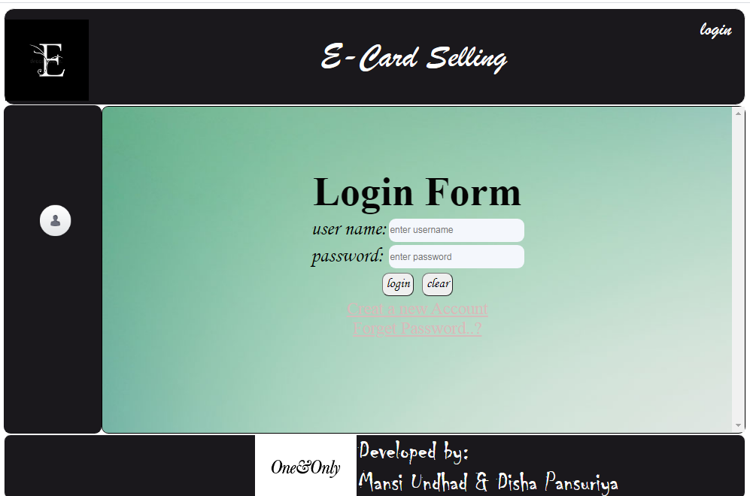

Registration

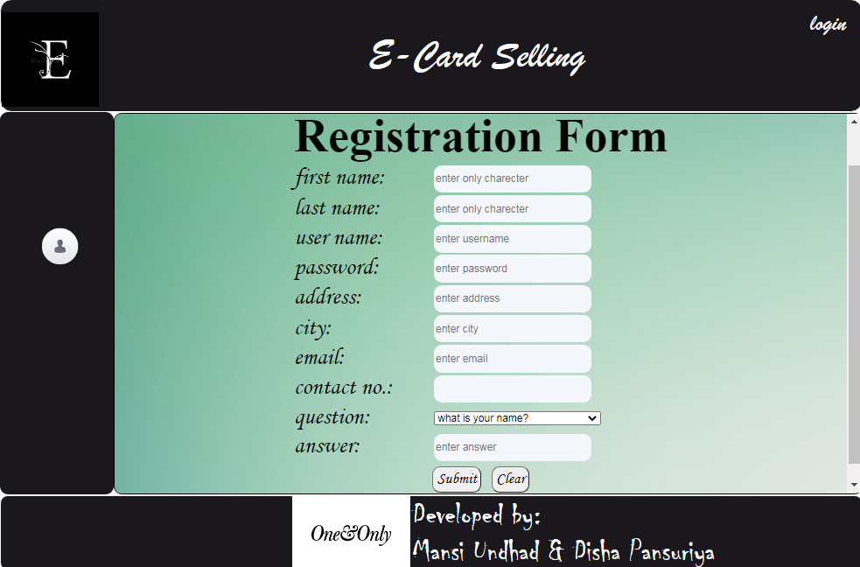

Forget user

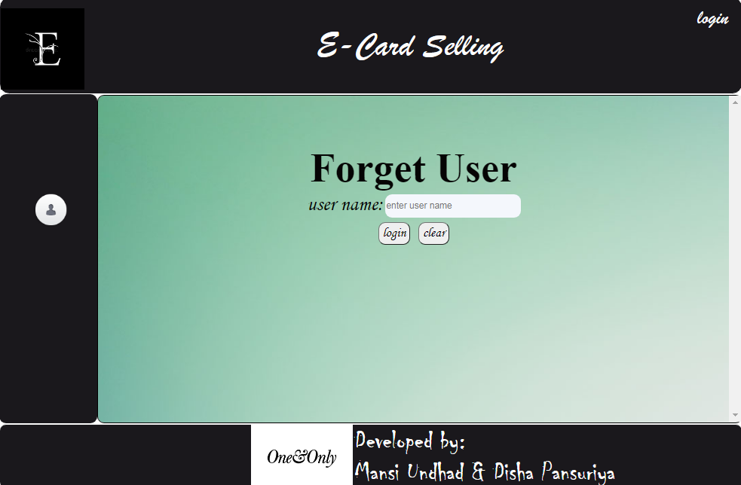

Forget answer

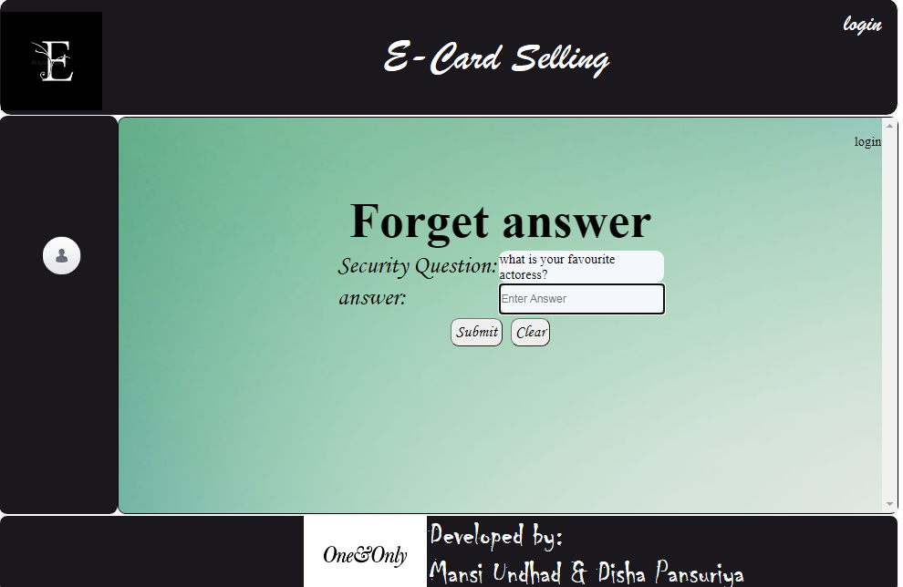

Forget password

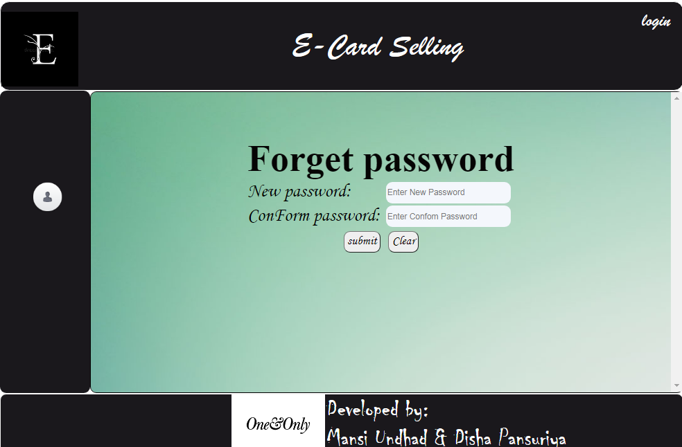

Change password

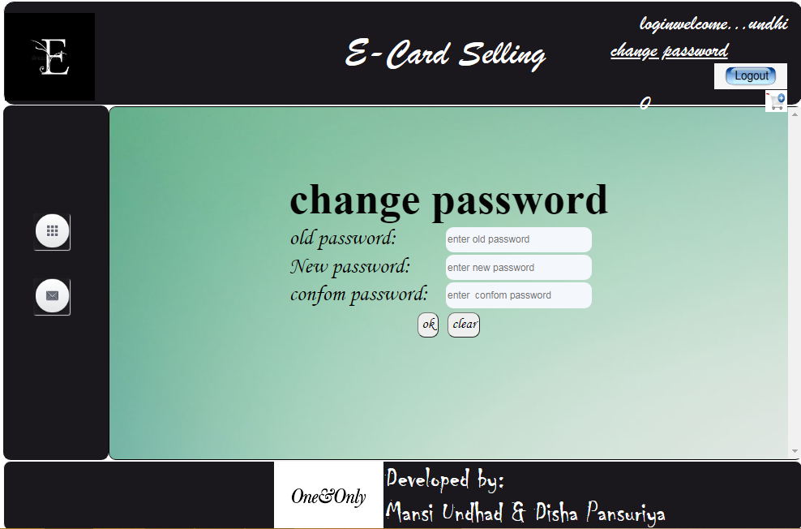

home

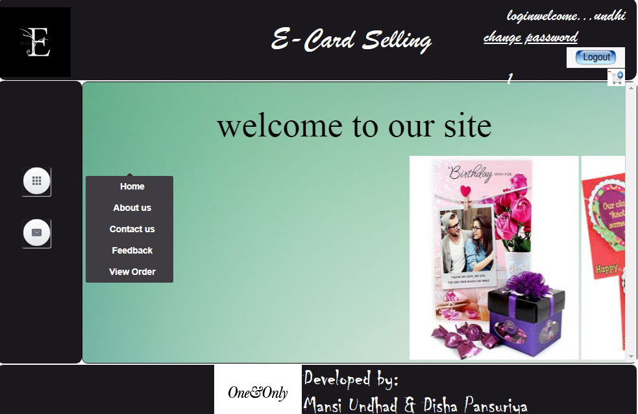

aboutus

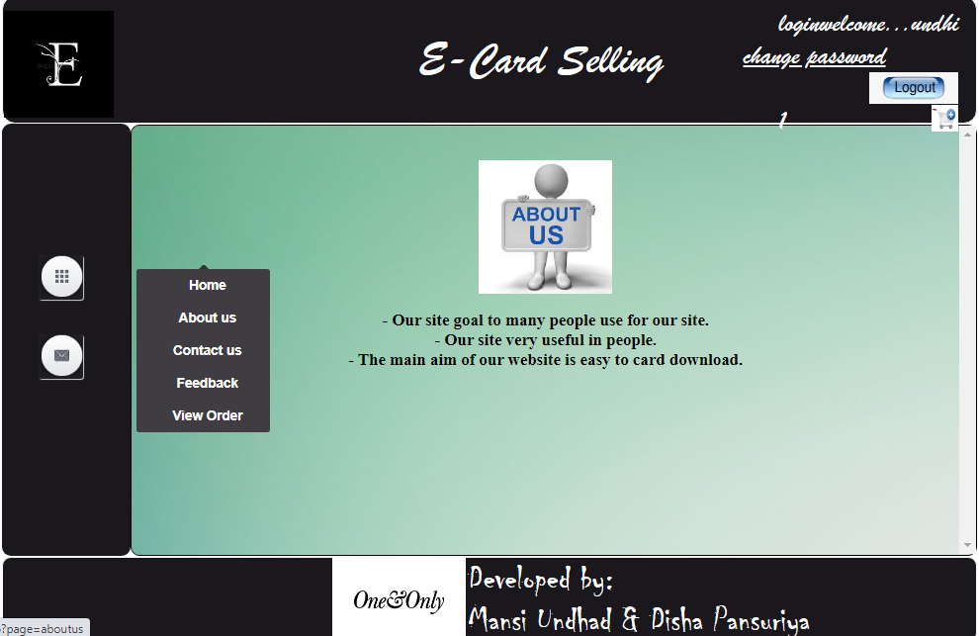

contactus

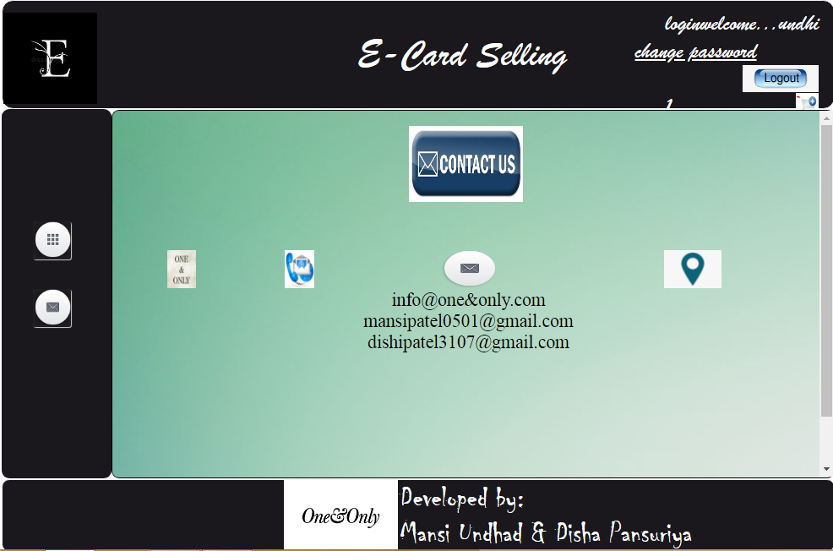

feedback

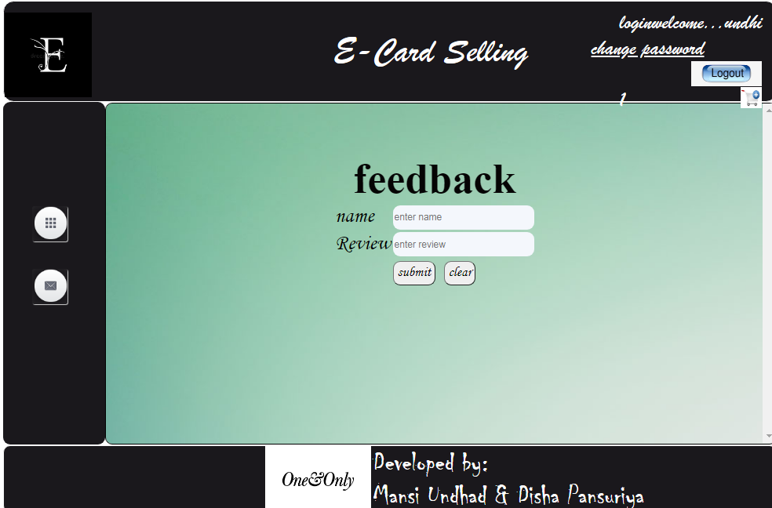

card

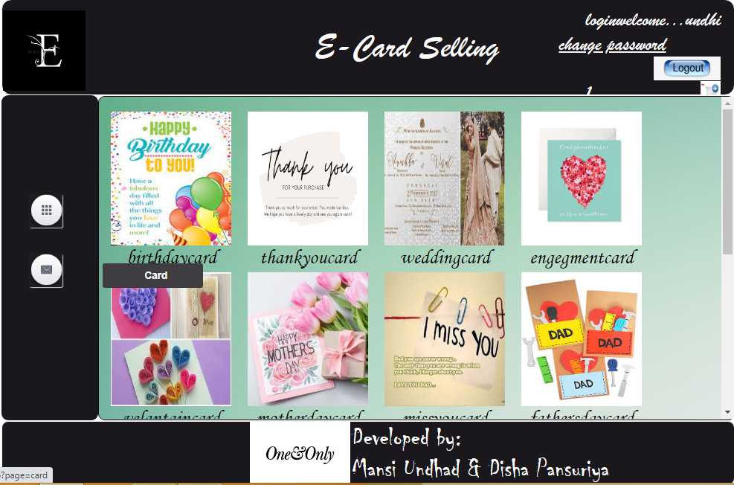

add

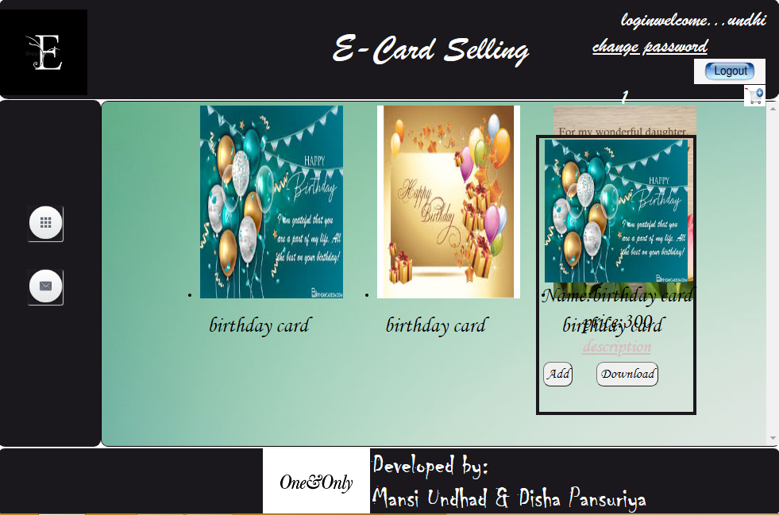

description

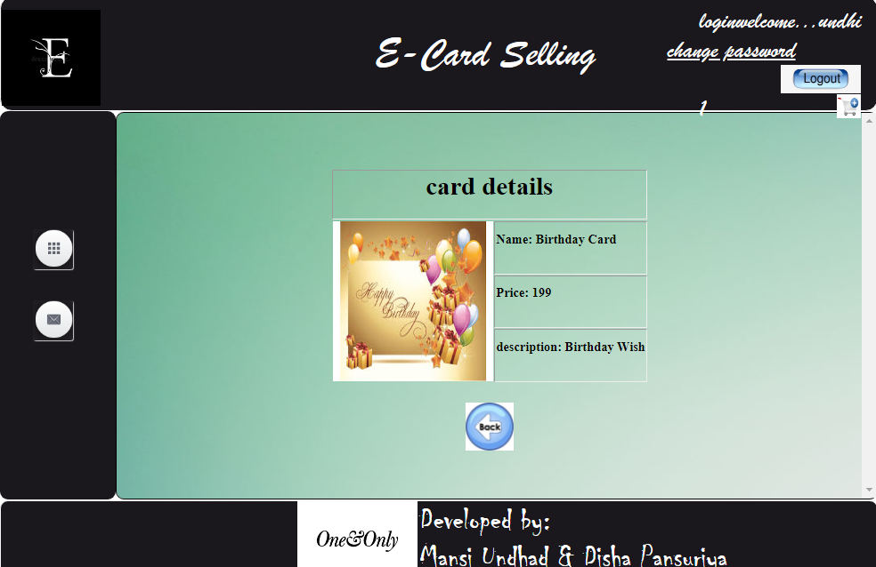

Product detail

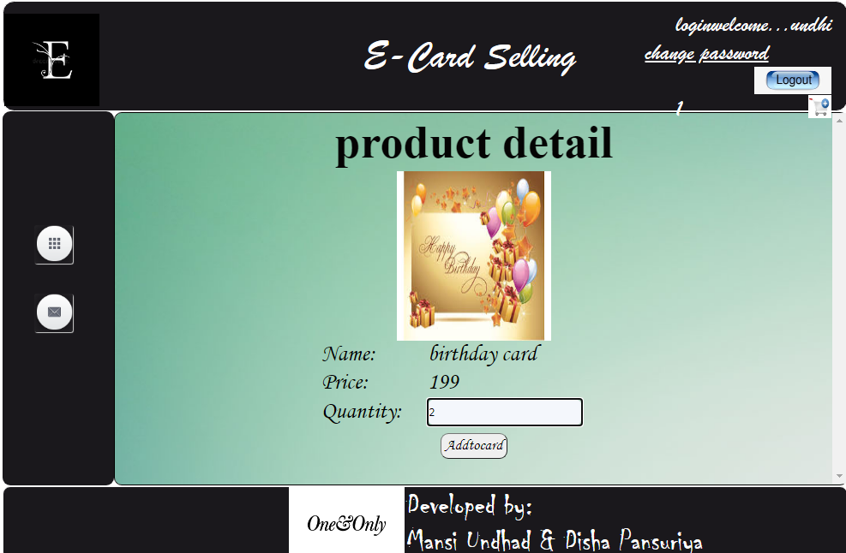

Add to card

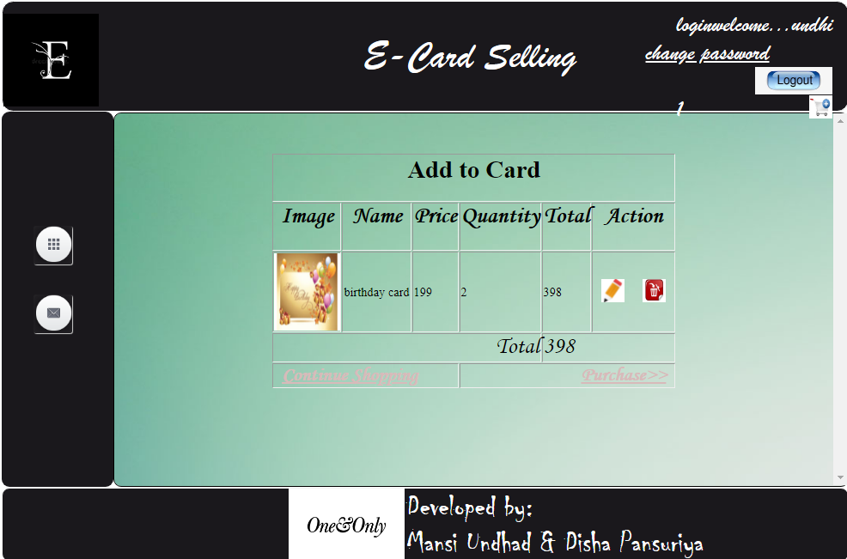

Purchase card

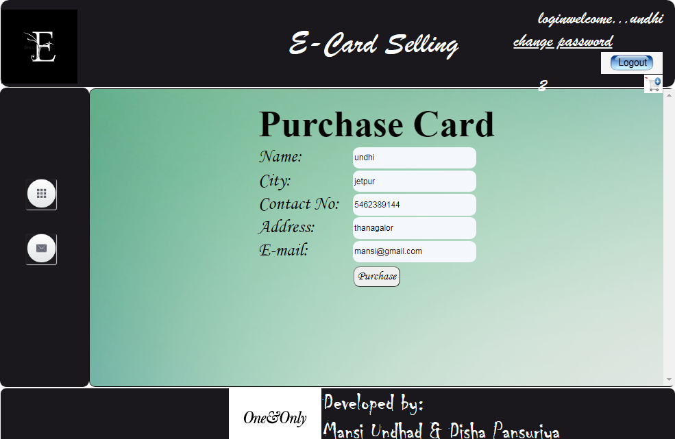

successfully

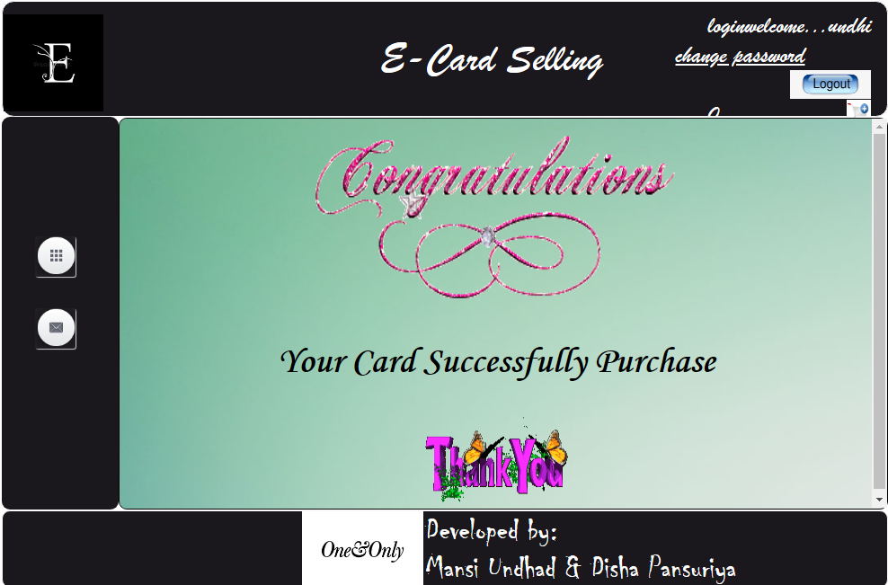

* Admin side

category

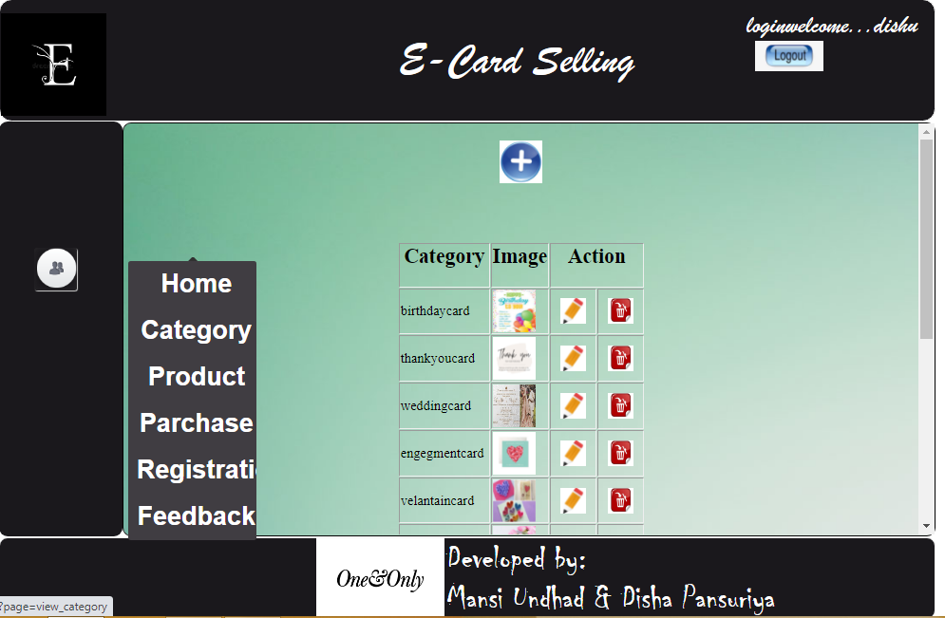

product

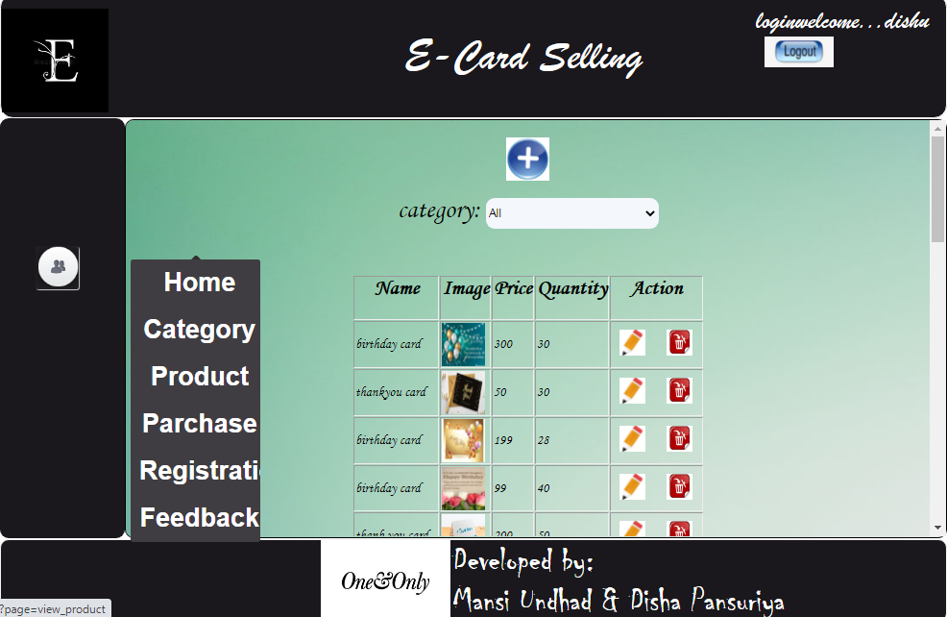

parchase

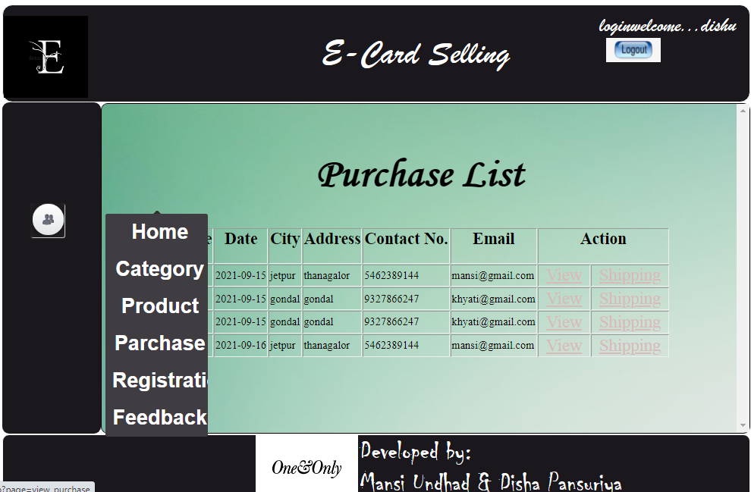

registration

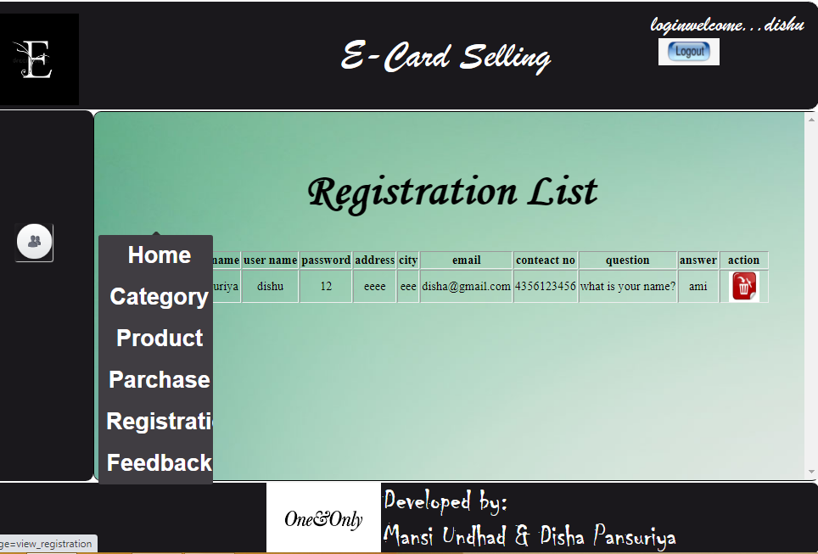

feedback

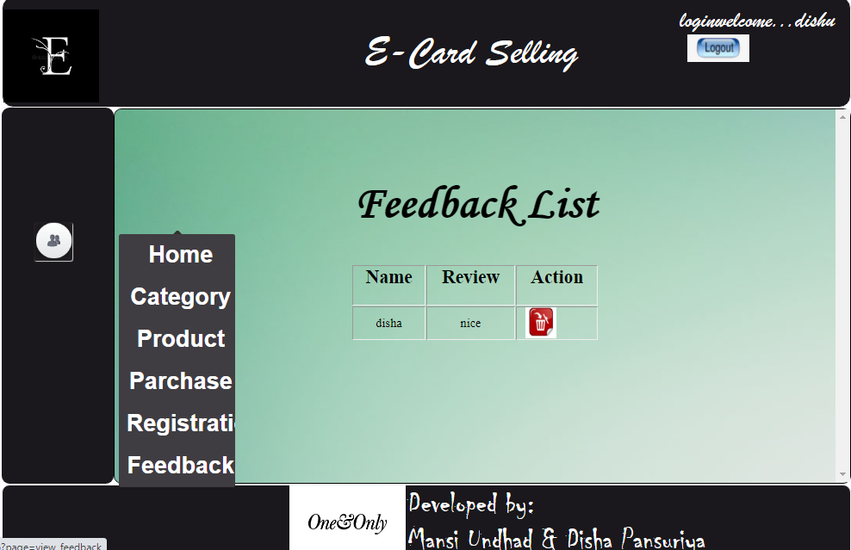

Add product

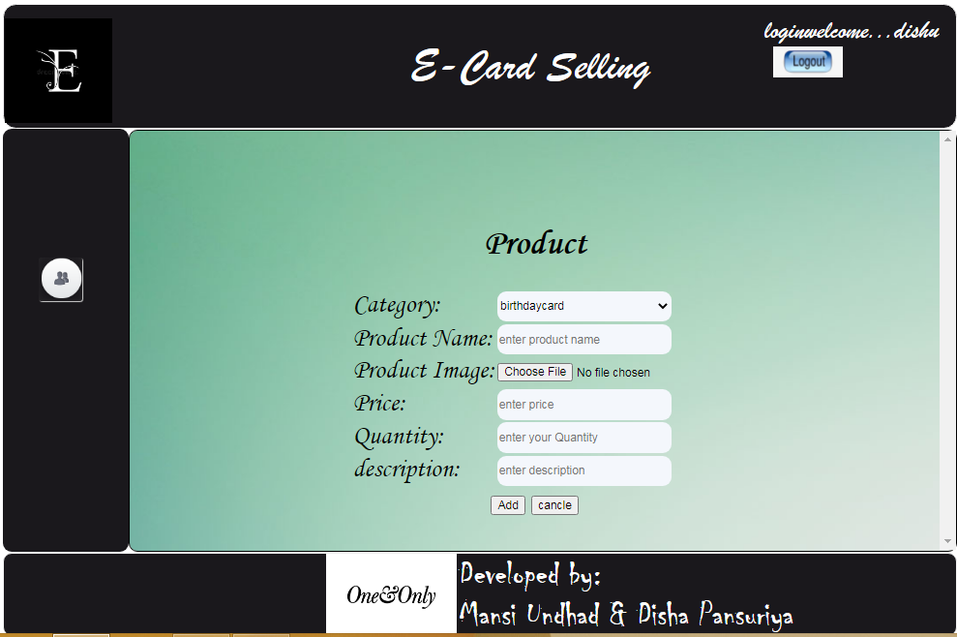

Add category

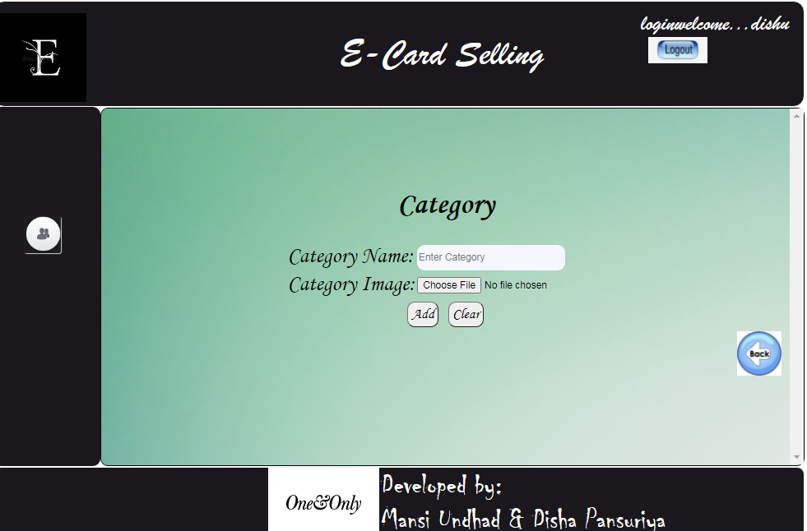

6. Coding

Index.php

<center>

<script type="text/javascript" language="javascript">

function f1()

{

return confirm("are you sure want to delet...");

}

function f2()

{

return confirm("are you sure want to edit...");

}

function f3()

{

return confirm("zsgdszg");

}

</script>

</center>

<html>

<head>

<link href="css/style.css" rel="stylesheet" type="text/css" >

</head>

<body>

<div id="wrapper">

<div id="header">

<div id="logo" class="float_left">

<img src="image/logo3.jpg" height="120px" width="124px">

</div>

<div id="title"><center> E-Card Selling</center>

</div>

<div id="login" class="float_right">

<?php

session_start();

include("connection.php");

if(isset($_SESSION['r_id']))

{

if($_SESSION['r_utype']==1)

{

echo "welcome...".$_SESSION['unm'];

echo "<br><a href='index.php?page=logout'><u><img src='image/logout.jpg' height='35px' width='80px' /></u></a>";

}

else

{

echo $_SESSION['r_unm'];

echo "welcome...".$_SESSION['unm'];

echo"<br><a href='index.php?page=changepassword' class='a'>change password</a>";

echo"<br><a href='index.php?page=logout' class='a'><u><img src='image/logout.jpg' height='35px' width='100px' align='right'/></u></a><br>";

$que="select a_p_qty from addtocard where a_r_id=".$_SESSION['r_id'];

$res=mysql_query($que,$con);

echo$row=mysql_num_rows($res);

echo "<a href='index.php?page=addtocard' class='a'><u><img src='image/addto.jpg' height='30px' width='30px' align='right' /></u></a>";

}

}

?>

</div>

</div>

<div id="menu" align="left" class="td">

<nav id="colorNav">

<ul><br/><br/>

<a href="index.php?page=main" class="a"></a><br><br>

<?php

if($_SESSION['r_id'])

{

session_start();

if(isset($_SESSION['r_id']))

{

if($_SESSION['r_utype']==1)

{

?>

<li>

<img src="aa/users.png" height="50px" width="50px" align="center" />

<ul>

<?php

echo "<li><a href='index.php?page=home' class='a'>Home</a></li>";

echo "<li><a href='index.php?page=view_category' class='a'>Category</a></li>";

echo "<li><a href='index.php?page=view_product' class='a'>Product</a></li>";

echo "<li><a href='index.php?page=view_purchase' class='a'>Parchase</a></li>";

echo "<li><a href='index.php?page=view_registration' class='a'>Registration</a></li>";

echo "<li><a href='index.php?page=view_feedback' class='a'>Feedback</a></li>";

?>

</ul>

</li><br/><br/>

<?php

}

else

{

?>

<li>

<img src="aa/grid.png" height="50px" width="50px" align="center" />

<ul>

<?php

echo "<li><a href='index.php?page=home' class='a1' >Home</a></li>";

echo "<li><a href='index.php?page=aboutus' class='a1'>About us</a></li>";

echo "<li><a href='index.php?page=contaus' class='a1'>Contact us</a></li>";

echo "<li><a href='index.php?page=feedback' class='a1'>Feedback</a></li>";

echo "<li><a href='index.php?page=oder' class='a1'>View Order</a></li>";

?>

</ul>

</li><br/><br/>

<li>

<img src="image/image.png" height="50px" width="50px" />

<ul>

<?php

echo "<li><a href='index.php?page=gellery' class='a1'>gellery</a></li>";

?>

</ul>

</li><br/><br/>

<li>

<img src="image/mail.png" height="50px" width="50px" />

<ul>

<?php

echo "<li><a href='index.php?page=card' class='a1'>Card</a></li>";

?>

</ul>

</li><br/><br/>

<?php

}

}

else

{

?>

<li>

<img src="image/grid.jpg" height="50px" width="50px" align="center" />

<ul>

<?php

echo "<li><a href='index.php?page=home' class='a1'>Home</a></li>";

echo "<li><a href='index.php?page=aboutus' class='a1'>About us</a></li>";

echo "<li><a href='index.php?page=contaus' class='a1'>Contact us</a></li>";

echo "<li><a href='index.php?page=feedback' class='a1'>Feedback</a></li>";

?>

</ul>

</li><br/><br/>

<li>

<img src="image/image.png" height="50px" width="50px" />

<ul>

<?php

echo "<li><a href='index.php?page=gellery' class='a1'>Gellery</a></li>";

?>

</ul>

</li><br/><br/>

<li>

<img src="image/mail.png" height="50px" width="50px" />

<ul>

<?php

echo "<li><a href='index.php?page=card' class='a1'>Card</a></li>";

?>

</ul>

</li><br/><br/>

<?php

}

}

else

{

?>

<a href="index.php?page=login"><img src="aa/male_user.png" height="50px" width="50px" align="center" /></a>

<?php

}

?>

</ul>

</nav>

</div><center>

<div id="content" align="right">

<?php

if(isset($_REQUEST['page']))

{

include "include/".$_REQUEST['page'].".php";

}

else

{

include "include/main.php";

}

?>

</div></center>

</ul>

</footer>

<div id="footer"<h1 align="left" style="font-size:40px;"><img src="image/one.png" align="left" height="100" width="150">Developed by:<br> Mansi Undhad & Disha Pansuriya</h1></div>

</div>

</body>

</html>

</div>

</body>

</html>

Connection.php

<?php

$con=mysql_connect("localhost","root","root");

$res=mysql_select_db("e_card",$con)or die ("database not found");

if($res)

{

echo "login";

}

else

{

echo mysql_error();

}

session_start();

?>

Include\aboutus.php

<br>

<center>

<!--<h1><u>About Us</u></h1>-->

<br>

<img src="image/aboutus.jpg" height="150x" width="150px" align="center"><br>

<h3 align="center">

-<f1> Our site goal to many people use for our site.</f1><br>

- Our site very useful in people.<br>

- The main aim of our website is easy to card download.<br>

</h3><br></br>

</center>

</br>

Add_category.php

<body>

<form action="action/cat_insert.php" name="frmchackpwd" method="POST" enctype="multipart/form-data" >

<?php

if(isset($_REQUEST['c_id']))

{

include("../connection.php");

$que="select * from category where c_id=".$_REQUEST['c_id'];

$res=mysql_query($que,$con);

$row=mysql_fetch_array($res);

}

?>

<br><br><br>

<table border="1" align="center" class="table">

<tr>

<th colspan="2" class="th"> <h1>Category</h1></th>

</tr>

<tr>

<td class="td">Category Name:</td>

<td class="td">

<input type="text" name="c_nm" value="<?php

if(isset($_REQUEST['c_id']))

{

echo $row['c_name'];

}

?>" placeholder="Enter Category" class="textbox" title="Enter Category" pattern="[A-z]{1,}" required>

</td>

</tr>

<tr>

<td class="td">Category Image:</td>

<td class="td">

<input type="file" name="file">

<input type="hidden" name="file" value="<?php

if(isset($_REQUEST['c_id']))

{

echo $row['c_image'];

}

?>">

<?php

if(isset($_REQUEST['c_id']))

{

echo "<img src='upload/".$row['c_image']."' height='80px' width='80px'>";

echo "<input type='hidden' name='file' value='".$row['c_image']."'>";

}

?>

</td>

</tr>

<tr>

<td colspan="2" align="center" class="td">

<?php

if(isset($_REQUEST['c_id']))

{

?>

<input type="hidden" name="c_id" value="<?php

echo $_REQUEST['c_id'];

?>">

<input type="submit" value="update" class="button">

<?php

}

else

{

?>

<input type="submit" value="Add" class="button">

<?php

}

?>

<input type="reset" value="Clear" class="button">

</td>

</tr>

</table>

<a href='index.php?page=view_category'><img src='image/back.jpg' height='60px' width='60px' /></a>

</form>

</body>

Add_product.php

<html>

<head>

<link rel="stylesheet" type="text/css" href="../style/style.css">

</head>

<body>

<form name="frmproduct" action="action/in_prodect.php" method="POST" enctype="multipart/form-data" onsubmit="returncheck_vaild();">

<br><br><br>

<table align="center" border="2s" class="table">

<th colspan="2" class="th" ><h1>Product</h1></th>

<tr>

<td class="td">Category:</td>

<td class="td">

<select name="c_id" class="textbox">

<?php

include("../connection.php");

$que="select * from category";

$res=mysql_query($que,$con);

while($row=mysql_fetch_array($res))

{

if(isset($_REQUEST['c_id']))

{

if($row['c_id']==$_REQUEST['c_id'])

{

echo "<option selected value=".$row['c_id'].">".$row['c_name']."</option>";

}

else

{

echo "<option value=".$row['c_id'].">".$row['c_name']."</option>";

}

}

else

{

echo "<option value=".$row['c_id'].">".$row['c_name']."</option>";

}

}

echo"</select>"

?>

</td>

</tr>

<?php

if(isset($_REQUEST['p_id']))

{

$query="select * from product where p_id=".$_REQUEST['p_id'];

$result=mysql_query($query,$con);

$row=mysql_fetch_array($result);

}

?>

<tr>

<td class="td">Product Name:</td>

<td class="td"><input type="text" name="p_nm" class="textbox" value="<?php

if(isset($_REQUEST['p_id']))

{

echo $row['p_nm'];

}

?>"placeholder="enter product name">

</td>

</tr>

<tr>

<td class="td">Product Image:</td>

<td class="td" ><input type="file" name="file">

<input type="hidden" name="file" value="<?php

if(isset($_REQUEST['p_id']))

{

echo $row['p_image'];

}

?>">

<?php

if(isset($_REQUEST['p_id']))

{

echo"<img src='upload/".$row['p_image']."'height='50px' width='50px' />";

echo"<input type='hidden' name='file' value='".$row['p_image']."'>";

}

?>

</td>

</tr>

<tr>

<td class="td">Price:</td>

<td class="td"><input type="text" class="textbox" name="p_price" value="<?php

if(isset($_REQUEST['p_id']))

{

echo $row['p_price'];

}

?>" placeholder="enter price">

</td>

</tr>

<tr>

<td class="td">Quantity:</td>

<td class="td">

<input type="text" name="p_qty" class="textbox" value="<?php

if(isset($_REQUEST['p_id']))

{

echo $row['p_qty'];

}

?>" placeholder="enter your Quantity">

</td>

</tr>

<tr>

<td class="td">description:</td>

<td class="td">

<input type="text" name="p_desc" class="textbox" value="<?php

if(isset($_REQUEST['p_id']))

{

echo $row['p_desc'];

}

?>" placeholder="enter description">

</td>

</tr>

<tr>

<td colspan="2" align="center" class="td">

<?php

if(isset($_REQUEST['p_id']))

{

{

echo"<input type='hidden' name='p_id' value=".$_REQUEST['p_id'].">";

echo"<input type='submit' name='Edit' value='Edit'>";

}

}

else

{

echo"<input type='submit' name='Add' value='Add'>";

}

?>

<input type="reset" name="cancle" value="cancle">

</td>

</tr>

</form>

</table>

</body>

</html>

Addtocard.php

<html>

<body>

<form>

<input type="hidden" name="p_id" value="<?php echo $_REQUEST['p_id'] ?>">

<input type="hidden" name="a_id" value="<?php echo $_REQUEST['a_id'] ?>">

<?php

include("../connection.php");

$query1="select * from addtocard where a_r_id=".$_SESSION['r_id'];

$result1=mysql_query($query1);

/* $que="select * from product where p_id= ".$_REQUEST['p_id'];

$res=mysql_query($que,$con);*/

?>

<table border="3" align="center" class="table">

<tr>

<td colspan="6" align="center"><h1>Add to Card</h1></td>

</tr>

<tr>

<th><h2 class="td">Image</h2></th>

<th><h2 class="td">Name</h2></th>

<th><h2 class="td">Price</h2></th>

<th><h2 class="td">Quantity</h2></th>

<th><h2 class="td">Total</h2></th>

<th><h2 class="td">Action</h2></th>

</tr>

<?php

while($row=mysql_fetch_array($result1))

{

echo"<tr>";

$query="select * from product where p_id=".$row['a_p_id'];

$result=mysql_query($query);

if($row1=mysql_fetch_array($result))

{

//$_SESSION['p_id']=$row[p_id];

echo"<td><img src='upload/".$row1['p_image']."'height='100px' width='85px'></td>";

echo"<td>".$row1['p_nm']."</td>";

echo"<td>".$row1['p_price']."</td>";

echo"<td>".$row['a_p_qty']."</td>";

echo"<td>".$tot=$row['a_p_qty']*$row1['p_price']."</td>";

echo"<td align='center'><a href='index.php?page=productdetail&p_id=".$row['a_p_id']."'>

<img src='image/adit.jpg' height='30' width='30'></a>

<a href='action/del_card.php?p_id=".$row['a_p_id']."'>

<img src='image/de.jpg' height='30' width='30'></a>

</td>";

$bill_tot+=$tot;

}

echo"</tr>";

}

?>

<tr class="td">

<td colspan="4" align="right">Total </td>

<td colspan="2" ><?php echo $bill_tot;?></td>

</tr>

<tr class="td">

<td colspan="3"><a href="index.php?page=card"><b>Continue Shopping</b></a></td>

<td colspan="3" align="right"><a href="index.php?page=purchase&total=<?php echo $bill_tot;?>"><b>Purchase>></b></td>

</tr>

</table>

</form>

</body>

</html>

Card.php

<div id="category">

<?php

include("../connection.php");

$que="select * from category";

$res=mysql_query($que,$con);

echo "<br>";

while($row=mysql_fetch_array($res))

{

echo "<table align='left'>";

echo "<tr>";

echo "<td align='center'><a href='index.php?page=subcard&c_id=".$row[0]."'>

<img src='upload/".$row['c_image']."' height='200px' width='180px'></a></td>";

echo "</tr>";

echo "<tr>";

echo "<td align='center' class='td'>".$row['c_name']."</td>";

echo "</tr>";

echo "</table>";

}

?>

</div>

Changepassword.php

<br>

<div>

<html>

<head>

<title>login</title>

<link href="../css/style.css" rel="stylesheet" type="text/css" >

</head>

<?php

if(isset($_REQUEST['msg']))

{

if($_REQUEST['msg']==1)

{

echo "<center><h2 class='td'><font color='red'> New Password & Conform Password Must Be Same </font></h2></center>";

}

if($_REQUEST['msg']==0)

{

echo "<center><h2 class='td'><font color='red'> Old Password Is Rong </font></h2></center>";

}

}

?>

<body>

<br>

<form action="action/check_password.php" name="frmchackpwd" method="POST" onsubmit="return check_validation();">

<table border="2" align="center" class="table" >

<tr>

<th colspan=2 class="title"> change password</th>

</tr>

<tr></tr>

<tr>

<td class="td">old password:</td>

<td class="td"><input type="password" name="c_opwd" placeholder="enter old password" class="textbox" pattern="[A-z]{1,}" required>

</td>

</tr>

<tr>

<td class="td">New password:</td>

<td class="td"><input type="password" name="c_npwd" placeholder="enter new password" class="textbox" pattern="[A-z]{1,}" required>

</td>

</tr>

<tr>

<td class="td">confom password:</td>

<td class="td"><input type="password" name="c_cpwd" placeholder="enter confom password" class="textbox" pattern="[A-z]{1,}" required>

</td>

</tr>

<tr>

<td align="center" colspan=2 class="td">

<input type="submit" value="ok" name="button" class="button">

<input type="reset" value="clear" name="button" class="button">

</td>

</tr>

</table>

</form>

</body>

</html>

Contactus.php

<!DOCTYPE html>

<html lang="en">

<head>

<meta charset="UTF-8">

<meta http-equiv="X-UA-Compatible" content="IE=edge">

<meta name="viewport" content="width=device-width, initial-scale=1.0">

<link rel="stylesheet" href="css/contact.css">

<link rel="preconnect" href="https://fonts.gstatic.com">

<link href="https://fonts.googleapis.com/css2?family=EB+Garamond&display=swap" rel="stylesheet">

<title>Contact</title>

</head>

<body>

<div class="container">

<div class="box">

<div class="icon">

<br> <img src="image/one4.jpg" height="50px" width="50px" alt="">

<h3>Ms. Mansi Undhad<br>

Ms. Disha Pansuriya </h3>

</div>

</div>

<div class="box">

<div class="icon">

<br> <img src="image/cont.jpg" height="50px" width="50px" alt="">

<h3> 9033162943<br>

8782242435<br>

9968473736

</h3>

</div>

</div>

<div class="box">

<div class="icon">

<br><img src="image/mail.png" height="50px" width="50px" alt="">

<h3>info@one&only.com <br>

mansipatel0501@gmail.com <br>

dishipatel3107@gmail.com

</h3>

</div>

</div>

<div class="box">

<div class="icon">

<br> <img src="image/add2.png" height="50px" width="50px" alt="">

<h3>155-s yogi chwok surat TB 395003 <br>

176-J Maruti Pazza Aheamdabad, TB 382350</h3>

</div>

</div>

</div>

</div>

</div>

</div>

</div>

</div>

<br><br><br><br><br><br><br><br><br><br>

</body>

</html>

Dow.php

<?php

include("../connection.php");

if(isset($_REQUEST['p_id']))

{

$que="select * from product where p_id=".$_REQUEST['p_id'];

$res=mysql_query($que,$con);

echo"<table align='center'><tr><br/><br/>";

while($row=mysql_fetch_array($res))

{

echo"<td>";

echo"<tr>";

echo"<center>";

echo"<img src='upload/".$row['p_image']."' border='3'height='200px' width='200px'><br/></br>";

echo"<td><a href='upload/".$row['p_image']."'download><img src='image/dw.png' height='45px' width='60px'></a></td>";

echo"</center>";

echo"</tr>";

echo"</table>";

echo"<a href='index.php?page=card'><img src='image/back.jpg'align='left'height='60px' width='60px'/></a>";

}

}

?>

Feedback.php

<br>

<div>

<center>

<form name="feedback" action="action/insertfeedback.php" method="POST">

<table border="2" align="center" class="table">

<tr>

<th colspan="2" class="title"> feedback </th>

</tr>

<tr>

<td class="td">name</td>

<td class="td"><input type="text" name="f_nm" placeholder="enter name" class="textbox" title="enter only charecter" pattern="[A-z]{1,}" required >

</td>

</tr>

<tr>

<td class="td">Review</td>

<td class="td"><input type="text" name="f_review" placeholder="enter review" class="textbox" pattern="[A-z]{1,}" required>

</tr>

<tr>

<td align="center" colspan=2 class="td">

<input type="submit" value="submit" name="button" class="button" class="td">

<input type="reset" value="clear" name="button" class="button">

</td>

</tr>

</table>

</center>

</div>

<br>

Forgetans.php

<br>

<div>

<html>

<head>

<title> online E-card shopping</title>

<link href="../css/style.css" rel="stylesheet" type="text/css" >

</head>

<body>

<?php

if(isset($_REQUEST['msg']))

{

if($_REQUEST['msg']==0)

{

echo "<center><h2 class='td'><font color='red'>Please Enter right answer</font></h2></center>";

}

}

?>

<form action="action/forget_ans.php" method="POST">

<?php

include("./connection.php");

$que="select * from registration where r_id=".$_REQUEST['r_id'];

$res=mysql_Query($que,$con);

$row=mysql_fetch_array($res);

$r_id=$row['r_id'];

?>

<input type="hidden" name="r_id" value="<?php echo $row['r_id'];?>">

<table align="center" class="table">

<tr>

<th colspan="2" align="center" class="title"> Forget answer</th>

</tr>

<tr>

<td class="td">Security Question:</td>

<td class="textbox">

<?php

echo $row['r_que'];

?>

</td>

</tr>

<tr>

<td class="td">answer:</td>

<td class="td"><input type="text" name="ans" placeholder="Enter Answer" class="textbox"></td>

</tr>

<tr>

<th align="center" colspan="2">

<input type="submit" value="Submit" name="submit" class="button">

<input type="reset" value="Clear" name="reset" class="button">

</th>

</tr>

</table>

</form>

</body>

</html>

</div>

<br>

Forgetpassword.php

<br>

<div>

<html>

<head>

<title> E-card selling</title>

<link href="../css/style.css" rel="stylesheet" type="text/css" >

</head>

<?php

if(isset($_REQUEST['msg']))

{

if($_REQUEST['msg']==0)

{

echo "<center><h2 class='td'><font color='red'> New Password & Conform Password Must Be Same </font></h2></center>";

}

}

?>

<body>

<form action="action/forget_pass.php" method="POST" onsubmit="return check_validation();">

<input type="hidden" name="r_id" value="<?php echo $_REQUEST['r_id'];?>">

<table border="1" align="center" class="table">

<tr>

<th colspan="2" align="center" class="title"> Forget password</th>

</tr>

<tr>

<td class="td">New password:</td>

<td class="td"><input type="password" name="pwd" placeholder="Enter New Password" title="Enter New Password" class="textbox">

</td>

</tr>

<tr>

<td class="td">ConForm password:</td>

<td class="td"><input type="password" name="cpwd" placeholder="Enter Confom Password" title="Enter Confom Password" class="textbox">

</td>

</tr>

<tr>

<th align="center" colspan="2" class="td">

<input type="submit" value="submit" name="button" class="button">

<input type="reset" value="Clear" name="button" class="button">

</th>

</tr>

</table>

</form>

</body>

</html>

</div>

<br>

Forgetuser.php

<div>

<html>

<head>

<title>Forget User</title>

<link href="../css/style.css" rel="stylesheet" type="text/css" >

</head>

<?php

if(isset($_REQUEST['msg']))

{

if($_REQUEST['msg']==0)

{

echo "<center><h2 class='td'><font color='red'>Invalid Username</font></h2></center>";

}

}

?>

<form action="action/forget_user.php" method="POST" onsubmit="return check_validation();">

<table border="2" align="center" class="table">

<tr>

<th colspan="2" align="center" class="title"> Forget User</th>

</tr><br/>

<tr></tr>

<tr>

<td class="td">user name:</td>

<td class="td"><input type="text" name="unm" placeholder="enter user name" class="textbox">

</td>

</tr>

<tr>

<td align="center" class="td" colspan=2>

<input type="submit" value="login" name="button" class="button">

<input type="reset" value="clear" name="button" class="button">

</td>

</tr>

</table>

</form>

</html>

</div>

Home.php

<html>

<head>

<title> e-card selling</title>

</head>

<?php

if(isset($_REQUEST['msg']))

{

if($_REQUEST['msg']==0)

{

echo "<center><h2 class='td'><font color='red'>Invalid Username & Password</font></h2></center>";

}

}

?>

<body>

<form name="frmlogin" action="action/checklogin.php" method="POST" >

<table border=2 align="center" class="table">

<tr>

<th colspan=2 class="title" > Login Form</th>

</tr>

<tr></tr>

<tr></tr><br/>

<tr>

<td class="td">user name:</td>

<td class="td"><input type="text" name="r_unm" placeholder="enter username" class="textbox" pattern="[A-z]{1,}" required title="Enter only charecter"></td>

</tr><br/>

<tr></tr>

<tr>

<td class="td">password:</td>

<td class="td"><input type="password" name="r_password" placeholder="enter password" class="textbox" required>

</td>

</tr>

<tr>

<td align="center" colspan=2 class="td">

<input type="submit" value="login" name="button" class="button">

<input type="reset" value="clear" class="button">

</td>

</tr>

</table>

<center>

<a href="index.php?page=registration">Creat a new Account</a>

<br/>

<a href="index.php?page=forgetuser">Forget Password..?</a>

</center>

</form>

<br/>

</body>

</html>

Home.php

<div>

<center>

<br><br>

<div class="title"><center>welcome to our site</center>

</div>

<br>

<marquee behavior="scroll" direction="left" scrollamount="10">

<img src="image/a.jpg" height="350px" width="290px" />

<img src="image/aa.jpg" height="350px" width="290px" />

<img src="image/aaa.jpg" height="350px" width="290px" />

<img src="image/b.jpg" height="350px" width="290px" />

<img src="image/bb.jpg" height="350px" width="290px" />

<img src="image/bbb.jpg" height="350px" width="290px" />

<img src="image/c.jpg" height="350px" width="290px" />

</marquee>

</center>

</div>

Login.php

<html>

<head>

<title> e-card selling</title>

</head>

<?php

if(isset($_REQUEST['msg']))

{

if($_REQUEST['msg']==0)

{

echo "<center><h2 class='td'><font color='red'>Invalid Username & Password</font></h2></center>";

}

}

?>

<body>

<form name="frmlogin" action="action/checklogin.php" method="POST" >

<table border=2 align="center" class="table">

<tr>

<th colspan=2 class="title" > Login Form</th>

</tr>

<tr></tr>

<tr></tr><br/>

<tr>

<td class="td">user name:</td>

<td class="td"><input type="text" name="r_unm" placeholder="enter username" class="textbox" pattern="[A-z]{1,}" required title="Enter only charecter"></td>

</tr><br/>

<tr></tr>

<tr>

<td class="td">password:</td>

<td class="td"><input type="password" name="r_password" placeholder="enter password" class="textbox" required>

</td>

</tr>

<tr>

<td align="center" colspan=2 class="td">

<input type="submit" value="login" name="button" class="button">

<input type="reset" value="clear" class="button">

</td>

</tr>

</table>

<center>

<a href="index.php?page=registration">Creat a new Account</a>

<br/>

<a href="index.php?page=forgetuser">Forget Password..?</a>

</center>

</form>

<br/>

</body>

</html>

Logout.php

<?php

session_destroy();

header("location:index.php?page=login");

?>

Main.php

<!DOCTYPE html>

<html>

<head>

<title>Demo 4 - with Navigation Buttons</title>

<link href="themes/home1/js-image-slider.css" rel="stylesheet" type="text/css" />

<script src="themes/home1/js-image-slider.js" type="text/javascript"></script>

<link href="generic.css" rel="stylesheet" type="text/css" />

</head>

<body>

<div id="slider">

<img src="image/b6.jpg" height="300px" width="200px" />

<img src="image/b9.jpg" height="300px" width="200px" />

<img src="image/1.6.jpg" height="250px" width="190px" />

<img src="image/b2.png" height="250px" width="190px" />

<img src="image/b9.jpg" height="250px" width="190px" />

<img src="image/fs6.png" height="250px" width="190px" />

<img src="image/fs7.jpg" height="250px" width="190px" />

</div>

<!--Custom navigation buttons on both sides-->

<!--nav bar-->

<script type="text/javascript">

//The following script is for the group 2 navigation buttons.

function switchAutoAdvance() {

imageSlider.switchAuto();

switchPlayPauseClass();

}

function switchPlayPauseClass() {

var auto = document.getElementById('auto');

var isAutoPlay = imageSlider.getAuto();

auto.className = isAutoPlay ? "group2-Pause" : "group2-Play";

auto.title = isAutoPlay ? "Pause" : "Play";

}

switchPlayPauseClass();

</script>

</body>

</html>

<html></html>

New.php

<br>

<body>

<form>

<input type="hidden" name="page" value="view_product"/>

<input type="hidden" name="p_id" value="$_REQUEST['p_id']">

<table border="2" align="center" class="table">

<tr>

<th colspan="6" class="b"><h1>Product</h1></th>

</tr>

<tr>

<th><h2>Image</th></h2>

<th><h2>Name</th></h2>

<th><h2>Price</th></h2>

<th><h2>Quantity</th></h2>

<th><h2>Total</th></h2>

</tr>

<?php

include("../connection.php");

//session_start();

$que="select * from bill1 where b1_id='".$_REQUEST['b1_id']."'&&b1_status='".(0)."'order by b1_id";

$res=mysql_query($que,$con);

while($row=mysql_fetch_array($res))

{

$que1="select * from bill2 where b2_b1_id='".$row['b1_id']."'";

$res1=mysql_query($que1,$con);

$row1=mysql_fetch_array($res1);

if($row1)

{

$que2="select * from product where p_id=".$row1['b2_p_id'];

$res2=mysql_query($que2,$con);

$row2=mysql_fetch_array($res2);

if($row2)

{

echo"<tr>";

echo"<td><img src='upload/".$row2['p_image']."' height='100px' width='80px'></td>";

echo"<td>".$row2['p_nm']."</td>";

echo"<td>".$row2['p_price']."</td>";

echo"<td>".$row1['b2_p_qty']."</td>";

echo"<td>".$tot=$row1['b2_p_qty']*$row2['p_price']."</td>";

$bill1=$tot;

echo"</tr>";

}

}

}

?>

<tr>

<th colspan="4" align="right"><h2>Total</h2></th>

<th colspan="2"><h2><?php echo $bill1;?></h2></th>

</tr>

</table>

<a href='index.php?page=view_purchase'><img src='image/back.jpg' height='60px' width='60px'/></a>

</form>

</body>

Oder.php

<body>

<form>

<input type="hidden" name="page" value="view_product"/>

<input type="hidden" name="p_id" value="$_REQUEST['p_id']">

<table border="2" align="center" class="table1">

<tr>

<th colspan="6" class="td"><h1>View Order </h1></th>

</tr>

<tr>

<th><h2>Image</th></h2>

<th><h2>Name</th></h2>

<th><h2>Price</th></h2>

<th><h2>Quantity</th></h2>

<th><h2>Total</th></h2>

</tr>

<?php

include("../connection.php");

session_start();

$que="select * from bill1 where b1_r_id='".$_SESSION['r_id']."'&&b1_status='".(0)."'order by b1_id";

$res=mysql_query($que,$con);

while($row=mysql_fetch_array($res))

{

$que1="select * from bill2 where b2_b1_id='".$row['b_id']."' ";

$res1=mysql_query($que1,$con);

while($row1=mysql_fetch_array($res1))

{

$que2="select * from product where p_id=".$row1['p_id'];

$res2=mysql_query($que2,$con);

if($row2=mysql_fetch_array($res2))

{

echo"<tr>";

echo"<td><img src='upload/".$row2['p_image']."' height='100px' width='80px'></td>";

echo"<td>".$row2['p_name']."</td>";

echo"<td>".$row2['p_price']."</td>";

echo"<td>".$row1['p_quantity']."</td>";

echo"<td>".$tot=$row1['p_quantity']*$row2['p_price']."</td>";

$bill1+=$tot;

echo"</tr>";

}

}

}

?>

<tr>

<th colspan="4" align="right"><h2>Total</h2></th>

<th colspan="2"><h2><?php echo $bill;?></h2></th>

</tr>

</table>

</form>

</body>

Productdescription.php

<?php

include("../connection.php");

session_start();

if(isset($_REQUEST['p_id']))

{

$query="select * from product where p_id=".$_REQUEST['p_id'];

$result=mysql_query($query,$con);

while($row=mysql_fetch_array($result))

{

echo"<center>";

echo"<table border='2' align='center' class='table'>";

echo"<th colspan='2'><h1>card details</h1></th><br/>";

echo"<tr><td rowspan='9' class='td' >";

echo"<img src='upload/".$row['p_image']."' height='200px' width='200px' class='td'></td></tr>";

echo"<tr><td ><h4>Name: ". ucWords($row['p_nm'])."</h4></td></tr>";

echo"<tr><td ><h4>Price: ".ucWords($row['p_price'])."</h4></td></tr>";

echo"<tr><td row='3'><h4>description: ".ucWords($row['p_desc'])."<h4></td></tr>";

echo"</center>";

echo"</table>";

echo"<h6><a href='index.php?page=card'><img src='image/back.jpg' height='60px' width='60px'></a></h6>";

echo mysql_error();

}

echo"<input type='hidden' name=p_id value=".$_REQUEST['p_id'].">";

}

?>

Productdetail.php

<html>

<head>

<title>product detail</title>

<link href="../style/style.css" rel="stylesheet" type="text/css">

</head>

<body>

<form action="action/insert_card.php" name="productdetail" method="POST" >

<input type="hidden" name="p_id" value="<?php echo $_REQUEST['p_id'] ?>">

<?php

include("../connection.php");

if(isset($_REQUEST['p_id']))

{

$que="select *from product where p_id=".$_REQUEST['p_id'];

}

else

{

$que="select *from product";

}

$res=mysql_query($que,$con);

$row=mysql_fetch_array($res);

?>

<table align="center" border="0" height='300' width='400' >

<tr>

<th colspan="2" class="title"> product detail </th>

</tr>

<td align="center" colspan="2" class="td"><img src="upload/<?php echo $row['p_image']; ?>" height='220' width='200'>

</td>

</tr>

<tr>

<td class="td">Name:</td><td class="td"pattern="[A-z]{1,}" required><?php echo $row['p_nm'];?></td>

</tr>

<tr>

<td class="td">Price:</td><td class="td"pattern="[0-9]{1,}" required><?php echo $row['p_price'];?></td>

</tr>

<tr>

<td class="td">Quantity:</td><td class="td"><input type="text" name="p_qty" class="textbox" title="enter only digit" pattern="[0-9]{1,}" required></td>

</tr>

<?php

if($_REQUEST['msg']==1)

{

echo"<center><h1>Out Of Stock...</h1></center>";

}

?>

<tr>

<td align="center" class="button" class="td" colspan="2" ><input type="submit" value="Addtocard" name="button" class="button"></td>

</tr>

</table>

</form>

</body>

</html>

Purchase.php

<br>

<form name="frmpurchase" action="action/insert_bill.php" method="POST">

<input type="hidden" name="total" value="<?php echo $_REQUEST['total'];?>">

<input type="hidden" name="b1_id" value="<?php echo $_REQUEST['b1_id'];?>">

<?php

include("../connection.php");

$que="select * from registration where r_id=".$_SESSION['r_id'];

$res=mysql_query($que,$con);

$row=mysql_fetch_array($res);

?>

<table border="0" align="center" >

<tr>

<th colspan="2" class="title">Purchase Card</th>

</tr>

<tr>

<td class="td">Name:</td>

<td class="td"><input type="text" name="p_nm" placeholder="enter name" class="textbox" value="<?php echo $row['r_unm']?>"

title="enter only charecter" pattern="[A-z]{1,}" required>

</tr>

<tr>

<td class="td">City:</td>

<td class="td"><input type="text" name="p_city" placeholder="enter city" class="textbox" value="<?php echo $row['r_city']?>"

title="enter only charecter" pattern="[A-z]{1,}" required>

</tr>

<tr>

<td class="td">Contact No:</td>

<td class="td"><input type="text" name="p_cont" placeholder="enter contact no" class="textbox" value="<?php echo $row['r_cont']?>" title="enter only 10 digit" pattern="[0-9]{1,}" required>

</tr>

<tr>

<td class="td">Address:</td>

<td class="td"><input type="text" name="p_add" placeholder="enter address" value="<?php echo $row['r_add']?>" class="textbox" required>

</tr>

<tr>

<td class="td">E-mail:</td>

<td class="td"><input type="email" name="p_email" placeholder="enter E-mail id" value="<?php echo $row['r_email']?>" class="textbox" required>

</tr>

<tr>

<td align="center" colspan="2" class="td">

<input type="submit" value="Purchase" name="button" class="button">

</td>

</tr>

</table>

</br>

</form>

</body>

Registration.php

<html>

<body>

<form name="frm_reg" action="action/insert_reg.php" method="POST" >

<?php

if($_REQUEST['msg']==1)

{

echo "<center><h1>".$_REQUEST['r_unm']."already

exists...</h1></center>";

}

?>

<table border="2" align="center" class="table">

<tr>

<th colspan="2" class="title"> Registration Form</th>

</tr>

<tr>

<td class="td">first name:</td>

<td class="td"><input type="text" name="r_fnm" placeholder="enter only charecter" class="textbox" title="enter only charecter" pattern="[A-z]{1,}" required>

</td>

</tr>

<tr>

<td class="td">last name:</td>

<td class="td"><input type="text" name="r_lnm" placeholder="enter only charecter" class="textbox" title="enter only charecter" pattern="[A-z]{1,}" required>

</td>

</tr>

<tr>

<td class="td">user name:</td>

<td class="td"><input type="text" name="r_unm" placeholder="enter username" class="textbox" title="enter only charecter" pattern="[A-z]{1,}" required>

</td>

</tr>

<tr>

<td class="td">password:</td>

<td class="td"><input type="password" name="r_password" placeholder="enter password" class="textbox" required >

</td>

</tr>

<tr>

<td class="td">address:</td>

<td class="td"><input type="text" name="r_add" placeholder="enter address" class="textbox" required >

</td>

</tr>

<tr>

<td class="td">city:</td>

<td class="td"><input type="text" name="r_city" placeholder="enter city" class="textbox" required >

</td>

</tr>

<tr>

<td class="td">email:</td>

<td class="td"><input type="text" name="r_email" placeholder="enter email" class="textbox" required >

</td>

</tr>

<tr>

<td class="td">contact no.:</td>

<td class="td"><input type="text" name="r_cont" placholder="enter contact no" class="textbox" title="enter only 10 digit" pattern="[0-9]{10}" required>

</tr>

<tr>

<td class="td">question:</td>

<td class="td"><select name="registration_question" required >

<option> what is your name?</option>

<option> what is your favourite song?</option>

<option> what is your favourite actor?</option>

<option> what is your favourite actoress?</option>

<option> what is your favourite food?</option>

<option> what is your favourite movie?</option>

<option> what is your favourite game?</option>

</select>

</td>

</tr>

<tr>

<td class="td">answer:</td>

<td class="td"><input type="password" name="registration_answer" placeholder="enter answer" class="textbox" required>

</td>

</tr>

<tr>

<td align="center" colspan=2 class="td">

<input type="Submit" value="Submit" name="button" class="button">

<input type="Reset" value="Clear" name="button" class="button">

</td>

</tr>

</table>

</form>

</body>

</html>

Shipping.php

<?php

include("../connection.php");

echo $_REQUEST['b1_id'];

echo $que="update bill1 set b1_status=".(1)." where b1_id=".$_REQUEST['b1_id'];

if(mysql_query($que))

header("location:index.php?page=view_purchase");

?>

Subcard.php

<nav id="product">

<?php

$que="select *from product ";

if(isset($_REQUEST['c_id']))

{

$que="select *from product where c_id=".$_REQUEST['c_id'];

}

else

{

$que="select *from product where c_id=c_id";

}

$tb=0;

$i=0;

$res=mysql_query($que);

echo "<table align='center'>";

echo "<tr>";

while($row=mysql_fetch_array($res))

{

echo "<td>";

echo "<table>";

echo"<tr>

<td><ul><li>

<img src='upload/".$row['p_image']."' height='270px' width='200px'>

<ul><table border='5' bordercolor='#1A181C'>

<tr><td class='td' colspan='2' align='center'><img src='upload/".$row['p_image']."' height='200px' width='200px'></td></tr>

<tr><td class='td' colspan='2' align='center'>Name:".$row['p_nm']."</td></tr>

<tr><td class='td' colspan='2' align='center'>price:".$row['p_price']."</td></tr>

<tr><td class='td' colspan='2' align='center'><a href='index.php?page=productdescription&p_id=".$row['p_id']."'>description</a></td></tr>

<tr><td class='td'>";

session_start();

if(isset($_SESSION['r_id']))

{

echo "<form action='index.php?page=productdetail&p_id=".$row['p_id']."' method='POST'>

<input type='Submit' value='Add' name='button' class='button'></form></td>";

echo "<td class='td'><form action='index.php?page=download&p_id=".$row['p_id']."' method='POST'>

<input type='Submit' value='Download' name='button' class='button'></form></td>";

}

echo "</tr>

</table>

</ul></li></ul> </td>

</tr>";

echo "<tr>";

echo "<td align='center' class='td'>".$row['p_nm']."</td>";

echo "</tr>";

echo"</table>";

echo "</td>";

}

echo"</table>";

echo "</td>";

?>

</nav>

Success.php

<body>

<center>

<img src='image/cong.gif' height='240px' width='450px' />

<font color="black" class="td"> <h2> Your Card Successfully Purchase </h2> </font>

<img src='image/thank.gif' height='120px' width='200px' />

</center>

</body>

View_category.php

<br>

<body>

<center>

<a href="index.php?page=add_category">

<img src='image/add.jpg' height='50' width='50' /></a>

<br>

<table border="1" align="center" class="table">

<tr>

<th><h2>Category</h2></th>

<th><h2>Image</h2></th>

<th colspan='2'><h2>Action</h2></th>

</tr>

<?php

include("../connection.php");

$que="select * from category ";

$res=mysql_query($que,$con);

while($row=mysql_fetch_array($res))

{

echo"<tr><td>".$row['c_name']."</td>

&nbsp;&nbsp;&nbsp;

<td><img src='upload/".$row['c_image']."' height='50px' width='50px'></td>

<td> <a href='index.php?page=add_category&c_id=".$row['c_id']."'>

<img src='image/adit.jpg' height='30' width='30' onclick='return f2()' /></a></td>

<td><a href='action/cat_delete.php?c_id=".$row['c_id']."'>

<img src='image/de.jpg' height='30' width='30' onclick='return f1()' /></a></td>

</tr>";

}

mysql_close($con);

?>

</table>

</center>

</body>

View_feedback.php

<br>

<html>

<head>

<title>Feedback List</title>

</head>

<?php

include("../connection.php");

$que="select * from feedback where f_id=f_id";

$result=mysql_query($que,$con);

?>

<center>

<tr> <br>

<table border="3" class="table" >

<th colspan="7" class="td">

<h1>Feedback List</h1>

</th>

</tr>

<th><h2>Name</h2></th>

<th><h2>Review</h2></th>

<th><h2>Action</h2></th>

<?php

while($row=mysql_fetch_array($result))

{

echo "<tr>

<td align='center'>".$row[f_nm]."</td>

<td align='center'>".$row[f_review]."</td>

<td>

<a href=action/del_feedback.php?f_id=".$row['f_id'].">

<img src='image/de.jpg' height='40' width='40' onclick='return f1()' />

</a>

</td>

</tr>";

}

mysql_close($con);

?>

</table>

</center>

</html>

<br>

View_product.php

<html>

<body>

<center>

<br>

<a href="index.php?page=add_product"><img src="image/add.jpg" height="50px" width="50px"/></a>

<br><br>

</center>

<form method="get">

<input type="hidden" name="page" value="view_product"/>

<input type="hidden" name="c_id" value="$_REQUEST['c_id']" />

<input type="hidden" name="p_id" value="$_REQUEST['p_id']" />

<center class='td'> category:

<select name="c_id" class='textbox'onchange="this.form.submit()">

<option value="c_id">All</option>

<?php

include("../connection.php");

$que="select * from category ";

$res=mysql_query($que,$con);

while($row=mysql_fetch_array($res))

{

if(isset($_REQUEST['c_id']))

{

if($row['c_id']==$_REQUEST['c_id'])

{

echo"<option selected value=".$row['c_id'].">".$row['c_name']."</option>";

}

else

{

echo"<option value=".$row['c_id'].">".$row['c_name']."</option>";

}

}

else

{

echo"<option value=".$row['c_id'].">".$row['c_name']."</option>";

}

//echo"</select>";

}

?>

</select><br><br>

</form>

<?php

if(isset($_REQUEST['c_id']))

{

$que="select * from product where c_id=".$_REQUEST['c_id'];

}

else

{

$que="select * from product where c_id=c_id";

}

echo"<table border='2' align='center' class='table1'>";

echo"<tr >";

echo"<th><h2>Name</h2></th>

<th><h2>Image</h2></th>

<th><h2>Price</h2></th>

<th><h2>Quantity</h2></th>

<th><h2>Action</h2></th>";

echo"</tr>";

include("../connection.php");

$res=mysql_query($que,$con);

$i=1;

while($row=mysql_fetch_array($res))

{

if($i==0)

{

echo"<tr><td>".$row['p_nm']."</td>

<td><img src='upload/".$row['p_image']."' height='50px' width='50px'></td>

<td>".$row['p_price']."</td>

<td>".$row['p_qty']."</td>

<td><a href='index.php?page=add_product&p_id=".$row['p_id']."'><img src='image/adit.jpg' height='30px' width='30px' onclick='return f2()'></a>

<a href='action/product_del.php?p_id=".$row['p_id']."'><img src='image/de.jpg' height='30px' width='30px' onclick='return f1()'></a></td>

</tr>";

$i=1;

}

else

{

echo"<tr><td>".$row['p_nm']."</td>

<td><img src='upload/".$row['p_image']."' height='50px' width='50px'></td>

<td>".$row['p_price']."</td>

<td>".$row['p_qty']."</td>

<td><a href='index.php?page=add_product&p_id=".$row['p_id']."'><img src='image/adit.jpg' height='30px' width='30px' onclick='return f2()'></a>

<a href='action/product_del.php?p_id=".$row['p_id']."'><img src='image/de.jpg' height='30px' width='30px' onclick='return f1()'></a></td>

</tr>";

$i=0;

}

}

echo"</table>";

?>

</body>

</html>

View_purchaase.php

<br>

<body>

<form>

<input type="hidden" name="p_id" value="<?php echo $_REQUEST['p_id'];?>" />

<table border=2 align="center" class="table">

<tr>

<th colspan="8" class="td"><h1>Purchase List</h1></th>

</tr>

<tr>

<th><h2>Name</h2></th>

<th><h2>Date</h2></th>

<th><h2>City</h2></th>

<th><h2>Address</h2></th>

<th><h2>Contact No.</h2></th>

<th><h2>Email</h2></th>

<th colspan="2"><h2>Action</h2></th>

</tr>

<?php

include("../connection.php");

$que="select * from bill1 where b1_status=0";

$res=mysql_query($que);

while($row=mysql_fetch_array($res))

{

echo"<tr>";

echo"<td>".$row['b1_nm']."</td>";

echo"<td>".$row['b1_date']."</td>";

echo"<td>".$row['b1_city']."</td>";

echo"<td>".$row['b1_adr']."</td>";

echo"<td>".$row['b1_cont']."</td>";

echo"<td>".$row['b1_eml']."</td>";

echo"<td><a href='index.php?page=view_purchase_product&b1_id=".$row['b1_id']."'>View</a></td>";

echo"<td><a href='index.php?page=shipping&b1_id=".$row['b1_id']."'>Shipping</a></td>";

echo"</tr>";

}

?>

</table>

</form>

</body>

View_purchase_product.php

<br>

<body>

<form>

<input type="hidden" name="page" value="view_product"/>

<input type="hidden" name="p_id" value="$_REQUEST['p_id']">

<table border="2" align="center" class="table">

<tr>

<th colspan="6" class="td"><h1>Product</h1></th>

</tr>

<tr>

<th><h2>Image</th></h2>

<th><h2>Name</th></h2>

<th><h2>Price</th></h2>

<th><h2>Quantity</th></h2>

<th><h2>Total</th></h2>

</tr>

<?php

include("../connection.php");

session_start();

$que="select * from bill1 where b1_id='".$_REQUEST['b1_id']."'&&b1_status='".(0)."'order by b1_id";

$res=mysql_query($que,$con);

while($row=mysql_fetch_array($res))

{

$que1="select * from bill2 where b2_b1_id='".$row['b1_id']."' ";

$res1=mysql_query($que1,$con);

while($row1=mysql_fetch_array($res1))

{

$que2="select * from product where p_id=".$row1['b2_p_id'];

$res2=mysql_query($que2,$con);

if($row2=mysql_fetch_array($res2))

{

echo"<tr>";

echo"<td><img src='../upload/".$row2['p_image']."' height='100px' width='80px'></td>";

echo"<td>".$row2['p_nm']."</td>";

echo"<td>".$row2['p_price']."</td>";

echo"<td>".$row1['b2_p_qty']."</td>";

echo"<td>".$tot=$row1['b2_p_qty']*$row2['p_price']."</td>";

$bill1+=$tot;

echo"</tr>";

}

}

}

?>

<tr>

<th colspan="4" align="right"><h2>Total</h2></th>

<th colspan="2"><h2><?php echo $bill1;?></h2></th>

</tr>

</table>

<a href='index.php?page=view_purchase'><img src='image/back.jpg' height='60px' width='60px'/></a>

</form>

</body>

View_registration.php

<html>

<head>

<title> View Record</title>

</head>

<?php

include("../connection.php");

$que="select * from registration where r_id=r_id&&r_utype='".(1)."'";

$result=mysql_query($que,$con);

?>

<center>

<tr> <br>

<table border="3" class="table">

<th colspan="11" class="td">

<h1>Registration List</h1>

</th>

</tr>

<th>first name</th>

<th>last name</th>

<th>user name</th>

<th>password</th>

<th>address</th>

<th>city</th>

<th>email</th>

<th>conteact no</th>

<th>question</th>

<th>answer</th>

<th>action</th>

<?php

while($row=mysql_fetch_array($result))

{

echo "<tr>

<td align='center'>".$row[r_fnm]."</td>

<td align='center'>".$row[r_lnm]."</td>

<td align='center'>".$row[r_unm]."</td>

<td align='center'>".$row[r_password]."</td>

<td align='center'>".$row[r_add]."</td>

<td align='center'>".$row[r_city]."</td>

<td align='center'>".$row[r_email]."</td>

<td align='center'>".$row[r_cont]."</td>

<td align='center'>".$row[r_que]."</td>

<td align='center'>".$row[r_ans]."</td>

<td>

<a href=action/reg_delete.php?r_id=".$row['r_id'].">

<img src='image/de.jpg' height='40' width='40' onclick='return f1()' />

</a>

</td>

</tr>";

}

mysql_close($con);

?>

</table>

</center>

</html>

</br>

Database\localehost.sql

-- phpMyAdmin SQL Dump

-- version 4.2.7.1

-- http://www.phpmyadmin.net

--

-- Host: localhost

-- Generation Time: Sep 07, 2021 at 07:05 AM

-- Server version: 5.6.20-log

-- PHP Version: 5.4.31

SET SQL_MODE = "NO_AUTO_VALUE_ON_ZERO";

SET time_zone = "+00:00";

/*!40101 SET @OLD_CHARACTER_SET_CLIENT=@@CHARACTER_SET_CLIENT */;

/*!40101 SET @OLD_CHARACTER_SET_RESULTS=@@CHARACTER_SET_RESULTS */;

/*!40101 SET @OLD_COLLATION_CONNECTION=@@COLLATION_CONNECTION */;

/*!40101 SET NAMES utf8 */;

--

-- Database: `e_card`

--

CREATE DATABASE IF NOT EXISTS `e_card` DEFAULT CHARACTER SET latin1 COLLATE latin1_swedish_ci;

USE `e_card`;

-- --------------------------------------------------------

--

-- Table structure for table `addtocard`

--

DROP TABLE IF EXISTS `addtocard`;

CREATE TABLE IF NOT EXISTS `addtocard` (

`a_id` int(10) NOT NULL,

`a_p_id` int(10) NOT NULL,

`a_r_id` int(10) NOT NULL,

`a_p_qty` int(10) NOT NULL

) ENGINE=MyISAM DEFAULT CHARSET=latin1 AUTO_INCREMENT=1 ;

-- --------------------------------------------------------

--

-- Table structure for table `bill1`

--

DROP TABLE IF EXISTS `bill1`;

CREATE TABLE IF NOT EXISTS `bill1` (

`b1_id` int(10) NOT NULL,

`b1_r_id` int(10) NOT NULL,

`b1_total` int(10) NOT NULL,

`b1_date` date NOT NULL,

`b1_nm` varchar(50) NOT NULL,

`b1_adr` text NOT NULL,

`b1_cont` text NOT NULL,

`b1_city` varchar(50) NOT NULL,

`b1_eml` varchar(50) NOT NULL,

`b1_status` tinyint(1) NOT NULL

) ENGINE=MyISAM DEFAULT CHARSET=latin1 AUTO_INCREMENT=1 ;

-- --------------------------------------------------------

--

-- Table structure for table `bill2`

--

DROP TABLE IF EXISTS `bill2`;

CREATE TABLE IF NOT EXISTS `bill2` (

`b2_id` int(10) NOT NULL,

`b2_b1_id` int(10) NOT NULL,

`b2_p_id` int(10) NOT NULL,

`b2_p_qty` int(50) NOT NULL

) ENGINE=MyISAM DEFAULT CHARSET=latin1 AUTO_INCREMENT=1 ;

-- --------------------------------------------------------

--

-- Table structure for table `category`

--

DROP TABLE IF EXISTS `category`;

CREATE TABLE IF NOT EXISTS `category` (

`c_id` int(10) NOT NULL,

`c_name` varchar(50) NOT NULL,

`c_image` varchar(50) NOT NULL

) ENGINE=MyISAM DEFAULT CHARSET=latin1 AUTO_INCREMENT=1 ;

-- --------------------------------------------------------

--

-- Table structure for table `feedback`

--

DROP TABLE IF EXISTS `feedback`;

CREATE TABLE IF NOT EXISTS `feedback` (

`f_id` int(10) NOT NULL,

`f_r_id` int(10) NOT NULL,

`f_nm` varchar(50) NOT NULL,

`f_eml` varchar(50) NOT NULL,

`f_add` text NOT NULL,

`f_cont` varchar(10) NOT NULL,

`f_city` varchar(10) NOT NULL,

`f_review` varchar(30) NOT NULL

) ENGINE=MyISAM DEFAULT CHARSET=latin1 AUTO_INCREMENT=1 ;

-- --------------------------------------------------------

--

-- Table structure for table `product`

--

DROP TABLE IF EXISTS `product`;

CREATE TABLE IF NOT EXISTS `product` (

`p-id` int(10) NOT NULL,

`c_id` int(20) NOT NULL,

`p_nm` varchar(50) NOT NULL,

`p_image` varchar(60) NOT NULL,

`p_price` varchar(50) NOT NULL,

`p_qty` int(20) NOT NULL,

`p_desc` varchar(50) NOT NULL

) ENGINE=MyISAM DEFAULT CHARSET=latin1 AUTO_INCREMENT=1 ;

-- --------------------------------------------------------

--

-- Table structure for table `registration`

--

DROP TABLE IF EXISTS `registration`;

CREATE TABLE IF NOT EXISTS `registration` (

`r_id` int(20) NOT NULL,

`r_fnm` varchar(20) NOT NULL,

`r_lnm` varchar(20) NOT NULL,

`r_unm` varchar(20) NOT NULL,

`r_password` varchar(20) NOT NULL,

`r_add` text NOT NULL,

`r_city` varchar(20) NOT NULL,

`r_email` varchar(20) NOT NULL,

`r_cont` varchar(20) NOT NULL,

`r_que` varchar(50) NOT NULL,

`r_ans` varchar(20) NOT NULL,

`r_utype` tinyint(1) NOT NULL

) ENGINE=MyISAM DEFAULT CHARSET=latin1 AUTO_INCREMENT=1 ;

--

-- Indexes for dumped tables

--

--

-- Indexes for table `addtocard`

--

ALTER TABLE `addtocard`

ADD PRIMARY KEY (`a_id`);

--

-- Indexes for table `bill1`

--

ALTER TABLE `bill1`

ADD PRIMARY KEY (`b1_id`);

--

-- Indexes for table `bill2`

--

ALTER TABLE `bill2`

ADD PRIMARY KEY (`b2_id`);

--

-- Indexes for table `category`

--

ALTER TABLE `category`

ADD PRIMARY KEY (`c_id`);

--

-- Indexes for table `feedback`

--

ALTER TABLE `feedback`

ADD PRIMARY KEY (`f_id`);

--

-- Indexes for table `product`

--

ALTER TABLE `product`

ADD PRIMARY KEY (`p-id`);

--

-- Indexes for table `registration`

--

ALTER TABLE `registration`

ADD PRIMARY KEY (`r_id`);

--

-- AUTO_INCREMENT for dumped tables

--

--

-- AUTO_INCREMENT for table `addtocard`

--

ALTER TABLE `addtocard`

MODIFY `a_id` int(10) NOT NULL AUTO_INCREMENT;

--

-- AUTO_INCREMENT for table `bill1`

--

ALTER TABLE `bill1`

MODIFY `b1_id` int(10) NOT NULL AUTO_INCREMENT;

--

-- AUTO_INCREMENT for table `bill2`

--

ALTER TABLE `bill2`

MODIFY `b2_id` int(10) NOT NULL AUTO_INCREMENT;

--

-- AUTO_INCREMENT for table `category`

--

ALTER TABLE `category`

MODIFY `c_id` int(10) NOT NULL AUTO_INCREMENT;

--

-- AUTO_INCREMENT for table `feedback`

--

ALTER TABLE `feedback`

MODIFY `f_id` int(10) NOT NULL AUTO_INCREMENT;

--

-- AUTO_INCREMENT for table `product`

--

ALTER TABLE `product`

MODIFY `p-id` int(10) NOT NULL AUTO_INCREMENT;

--

-- AUTO_INCREMENT for table `registration`

--

ALTER TABLE `registration`

MODIFY `r_id` int(20) NOT NULL AUTO_INCREMENT;

/*!40101 SET CHARACTER_SET_CLIENT=@OLD_CHARACTER_SET_CLIENT */;

/*!40101 SET CHARACTER_SET_RESULTS=@OLD_CHARACTER_SET_RESULTS */;

/*!40101 SET COLLATION_CONNECTION=@OLD_COLLATION_CONNECTION*/;

Action\cat_delete.php

<?php

require_once("../connection.php");

echo $que="delete from category where c_id=".$_REQUEST['c_id'];

if(mysql_query($que,$con))

{

echo $que="delete from product where c_id=".$_REQUEST['c_id'];

if(mysql_query($que,$con))

{

header("location:../index.php?page=view_product");

echo "delete";

}

else

{

echo mysql_error();

}

header("location:../index.php?page=view_category");

}

else

{

echo mysql_error();

}

?>

Cat_insert.php

<?php

include("../connection.php");

//echo "<br><br>".$_SESSION['c_id']."<br>";

echo $_FILES["file"]["name"];

if ((($_FILES["file"]["type"]=="image/jpg")

|| ($_FILES["file"]["type"] == "image/gif")

|| ($_FILES["file"]["type"] == "image/png")

|| ($_FILES["file"]["type"] == "image/pjpeg"))

&& ($_FILES["file"]["size"] < 20000))

{

if ($_FILES["file"]["error"] > 0)

{

echo "Return Code: " . $_FILES["file"]["error"] . "<br />";

}

else

{

echo "Upload: " . $_FILES["file"]["name"] . "<br />";

echo "Type: " . $_FILES["file"]["type"] . "<br />";

echo "Size: " . ($_FILES["file"]["size"] / 1024) . " <br />";

echo "Temp file: " . $_FILES["file"]["tmp_name"] . "<br />";

if (file_exists("../../upload/" . $_FILES["file"]["name"]))

{

echo $_FILES["file"]["name"] . " already exists. ";

}

else

{

move_uploaded_file($_FILES["file"]["tmp_name"],"../../upload/" . $_FILES["file"]["name"]);

echo "Stored in: " . "../../upload/" . $_FILES["file"]["name"];

}

}

}

else

{

echo "Invalid file";

}

echo $id=$_REQUEST[c_id];

if(isset($id))

{

if($_FILES["file"]["name"]=="")

{

$que="select *from category where c_id=".$_REQUEST['c_id'];

$res=mysql_query($que,$con);

$row=mysql_fetch_array($res);

$_FILES["file"]["name"]=$row['c_image'];

}

echo $que="update category set c_name='".$_REQUEST['c_nm']."',c_image='".$_FILES["file"]["name"]."' where c_id=".$_REQUEST['c_id'];

if(mysql_query($que,$con))

{

header("location:../index.php?page=view_category");

echo "selected";

}

else

{

header("location:../index.php?page=add_category&c_id=".$_REQUEST['c_id']);

//echo mysql_error();

}

}

else

{

echo $que="insert into category(c_name,c_image)values('".$_REQUEST['c_nm']."','".$_FILES["file"]["name"]."')";

if(mysql_query($que,$con))

{

header("location:../index.php?page=view_category");

//echo "selected";

}

else

{

header("location:../index.php?page=add_category");

}

}

mysql_close($con);

?>

Check_password.php

<?php

//require_once("../connection.php");

include("../connection.php");

echo $opwd=$_REQUEST['c_opwd'];

echo $npwd=$_REQUEST['c_npwd'];

echo $cpwd=$_REQUEST['c_cpwd'];

session_start();

echo $que="select * from registration where r_id=".$_SESSION['r_id']." && r_utype=".(0);

$res=mysql_query($que,$con);

if($row=mysql_fetch_array($res))

{

$pwd=$row['r_password'];

if($opwd==$pwd)

{

if($npwd==$cpwd)

{

echo $que="update registration set r_password='".$npwd."' where r_id=".$_SESSION['r_id'];

if(mysql_query($que,$con))

{

header("location:../index.php?page=home");

echo "password is chang";

}

else

{

echo "Not chang";

header("location:../index.php?page=changepassword&msg=1");

mysql_error();

}

}

else

{

echo "No chang";

header("location:../index.php?page=changepassword&msg=1");

mysql_error();

}

}

else

{

echo "No";

header("location:../index.php?page=changepassword&msg=0");

}

}

else

{

echo "No";

header("location:../index.php?page=changepassword&msg=0");

}

?>

Checklogin.php

<?php

//require_once("../connection.php");

include("../connection.php");

$unm=$_REQUEST['r_unm'];

$password=$_REQUEST['r_password'];

echo $que="select * from registration where r_unm='".$unm."' && r_password='".$password."'";

$result=mysql_query($que,$con);

if($row=mysql_fetch_array($result))

{

session_start();

echo $_SESSION['unm']=$row['r_unm'];

echo $_SESSION['r_utype']=$row['r_utype'];

echo $_SESSION['r_id']=$row['r_id'];

header("location:../index.php?page=home");

}

else

{

header("location:../index.php?page=login&msg==0");

}

?>

Del_card.php

<?php

include("../connection.php");

//session_start();

$que="delete from addtocard where a_p_id='".$_REQUEST['p_id']."' and a_r_id='".$_SESSION['r_id']."'";

if(mysql_query($que,$con))

{

//echo "deleted";

header("location:../index.php?page=addtocard");

}

else

{

echo mysql_error();

}

?>

Del_feedback.php

<?php

require_once("../connection.php");

$que="delete from feedback where f_id=".$_REQUEST[f_id];

mysql_query($que,$con);

header("location:../index.php?page=view_feedback");

?>

Fed_delet.php

<?php

require_once("../connection.php");

$que="delete from feedback where f_id=".$_REQUEST[f_id];

mysql_query($que,$con);

header("location:../index.php?page=view_feedback");

?>

Forget_ans.php

<?php

include("../connection.php");

echo $ans=$_REQUEST['r_ans'];

echo $rid=$_SESSION['f_r_id'];

echo $que="select * from registration where r_id=".$rid;

$res=mysql_Query($que,$con);

$row=mysql_fetch_array($res);

$rans=$row['r_ans'];

if($_REQUEST['ans']==$row['r_ans'])

{

header("location:../index.php?page=forgetpassword&r_id=".$rid);

echo "selected";

}

else

{

header("location:../index.php?page=forgetans&r_id=".$rid."&msg==0.");

echo " not selected";

}

?>

Forget_pass.php

<?php

//require_once("../connection.php");

include("../connection.php");

$npwd=$_REQUEST['pwd'];

$cpwd=$_REQUEST['cpwd'];

session_start();

echo $que="select * from registration where r_id=".$_SESSION['f_r_id'];

echo $res=mysql_query($que,$con);

$row=mysql_fetch_array($res);

if($npwd==$cpwd)

{

echo $que="update registration set r_password='".$npwd."' where r_id=".$_SESSION['f_r_id'];

if(mysql_query($que,$con))

{

header("location:../index.php?page=login");

}

else

{

header("location:../index.php?page=forgetpassword&r_id=".$_SESSION['f_r_id']."&msg==0.");

}

}

else

{

header("location:../index.php?page=forgetpassword&r_id=".$_SESSION['f_r_id']."&msg==0.");

}

//session_destroy();

?>

Forget_user.php

<?php

include("../connection.php");

$runm=$_REQUEST['unm'];

echo $que="select * from registration where r_unm='".$runm."'";

$res=mysql_Query($que,$con);

$row=mysql_fetch_array($res);

$r_id=$row['r_id'];

echo $utype=$row['r_utype'];

if(isset($r_id)&&$utype==(0))

{

$_SESSION['f_r_id']=$r_id;

header("location:../index.php?page=forgetans&r_id='".$r_id."'");

}

else

{

header("location:../index.php?page=forgetuser&msg==0");

}

?>

In_prodect.php

<?php

include("../connection.php");

//echo "<br><br>".$_SESSION['p_id']."<br>";

echo $_FILES["file"]["name"];

if ((($_FILES["file"]["type"]=="image/jpg")

|| ($_FILES["file"]["type"] == "image/gif")

|| ($_FILES["file"]["type"] == "image/png")

|| ($_FILES["file"]["type"] == "image/pjpeg"))

&& ($_FILES["file"]["size"] < 20000))

{

if ($_FILES["file"]["error"] > 0)

{

echo "Return Code: " . $_FILES["file"]["error"] . "<br />";

}

else

{

echo "Upload: " . $_FILES["file"]["name"] . "<br />";

echo "Type: " . $_FILES["file"]["type"] . "<br />";

echo "Size: " . ($_FILES["file"]["size"] / 1024) . " <br />";

echo "Temp file: " . $_FILES["file"]["tmp_name"] . "<br />";

if (file_exists("../../upload/" . $_FILES["file"]["name"]))

{

echo $_FILES["file"]["name"] . " already exists. ";

}

else

{

move_uploaded_file($_FILES["file"]["tmp_name"],"../../upload/" . $_FILES["file"]["name"]);

echo "Stored in: " . "../../upload/" . $_FILES["file"]["name"];

}

}

}

else

{

echo "Invalid file";

}

$id=$_REQUEST[p_id];

if(isset($id))

{

if($_FILES["file"]["name"]=="")

{

$que="select *from product where p_id=".$_REQUEST['p_id'];

$res=mysql_query($que,$con);

$row=mysql_fetch_array($res);

$_FILES["file"]["name"]=$row['p_image'];

}

//$cid=$_REQUEST['c_id'];

echo $que="update product set c_id='".$_REQUEST['c_id']."',p_nm='".$_REQUEST['p_nm']."',p_image='".$_FILES["file"]["name"]."',p_price='".$_REQUEST['p_price']."',p_qty='".$_REQUEST['p_qty']."',p_desc='".$_REQUEST['p_desc']."' where p_id=".$_REQUEST['p_id'];

if(mysql_query($que,$con))

{

header("location:../index.php?page=view_product");

//echo "selected";

}

else

{

header("location:../index.php?page=add_product&p_id=".$_REQUEST['p_id']);

//echo mysql_error();

}

}

else

{

echo $que="select *from product where c_id=".$_REQUEST['c_id'];

$res=mysql_query($que,$con);

$row=mysql_fetch_array($res);

$que1="insert into product(c_id,p_nm,p_image,p_price,p_qty,p_desc)values

('".$_REQUEST['c_id']."','".$_REQUEST['p_nm']."','".$_FILES["file"]["name"]."','".$_REQUEST['p_price']."','".$_REQUEST['p_qty']."','".$_REQUEST['p_desc']."')";

if(mysql_query($que1,$con))

{

header("location:../index.php?page=view_product");

//echo "selected";

}

else

{

header("location:../index.php?page=add_product&p_id=".$_REQUEST['p_id']);

//echo mysql_error();

}

}

mysql_close($con);

?>

Insert_bill.php

<?php

include("../connection.php");

$total=$_REQUEST['total'];

echo $que1="insert into bill1(b1_r_id,b1_total,b1_date,b1_nm,b1_adr,b1_cont,b1_eml,b1_city,b1_status)

values('".$_SESSION['r_id']."',

'".$_REQUEST['total']."',

'".date("y-m-d")."',

'".$_REQUEST['p_nm']."',

'".$_REQUEST['p_add']."',

'".$_REQUEST['p_cont']."',

'".$_REQUEST['p_email']."',

'".$_REQUEST['p_city']."',

'".(0)."')";

$res1=mysql_query($que1,$con);

if($res1)

{

echo "<br> inserted";

}

else

{

echo "<br> Not inserted";

}

$query="select * from bill1 order by b1_id ";

$result=mysql_query($query,$con);

while($row1=mysql_fetch_array($result))

{

$b1_id=$row1['b1_id'];

}

$b1_id;

echo $que3="select * from addtocard where a_r_id=".$_SESSION['r_id'];

$res3=mysql_query($que3,$con);

if($res3)

{

echo "<br> Yes";

}

echo"<br>".$p_qty=$row1['p_qty'] - $row['a_p_qty'];

while($row=mysql_fetch_array($res3))

{

echo $que4="select * from product where p_id= ".$row['a_p_id'];

$res4=mysql_query($que4,$con);

if($res4)

{

echo "select<br>";

while($row1=mysql_fetch_array($res4))

{

echo"<br>".$p_qty=$row1['p_qty'] - $row['a_p_qty'];

$que="update product set p_qty=".$p_qty." where p_id=".$row['a_p_id'];

$res=mysql_query($que,$con);

if($res)

{

echo "<br> updated";

}

else

{

echo "<br> Not updated";

}

echo $query2="insert into bill2(b2_b1_id,b2_p_id,b2_p_qty)values('".$b1_id."','".$row['a_p_id']."','".$row['a_p_qty']."')";

if($res=mysql_query($query2,$con))

{

echo "<br> inserted";

echo $qry1="delete from addtocard where a_r_id=".$_SESSION['r_id'];

echo $res=mysql_query($qry1,$con);

if($res)

{

echo "<br><br><br> deleted";

header("location:../index.php?page=success");

}

else

{

echo "<br><br><br> not deleted";

}

}

else

{

echo "<br> Not inserted in Bill2 record";

}

}

}

else

{

echo "<br> Not selected";

}

}

?>

Insert_card.php

<?php

include("../connection.php");

session_start();

echo $que="select * from product where p_id=".$_REQUEST['p_id'];

$res=mysql_query($que,$con);

$row=mysql_fetch_array($res);

if($_REQUEST['p_quantity']<=$row['p_qty'])

{

echo$que1="select * from addtocard where a_r_id=".$_SESSION['r_id']."&&a_p_id=".$row['p_id'];

$res1=mysql_query($que1,$con);

$row1=mysql_fetch_array($res1);

$aid=$row1['a_id'];

$quantity=$row1['a_p_qty'];

$que=$_REQUEST['p_quantity'];

$q=$quantity+$que;

if($aid)

{

echo $query="update addtocard set a_p_qty='".$_REQUEST['p_qty']."' where a_p_id='".$_REQUEST['p_id']."'";

$res=mysql_query($query,$con);

if($res)

{

header("location:../index.php?page=addtocard&a_id=".$_REQUEST['a_id']."&p_id=".$row['p_id']."&a_p_qty=".$_REQUEST['p_qty']);

echo "select";

}

else

{

header("location:../index.php?page=productdetail&p_id=".$_REQUEST['p_id']);

echo mysql_error();

}

}

else

{

echo "<br/>".$_REQUEST['p_quantity']."<=".$row['p_qty'];

session_start();

echo $query="insert into addtocard(a_p_id,a_r_id,a_p_qty)values('".$_REQUEST['p_id']."','".$_SESSION['r_id']."','".$_REQUEST['p_qty']."')";

$result=mysql_query($query,$con);

if($result)

{

header("location:../index.php?page=addtocard&a_id=".$_REQUEST['a_id']."&p_id=".$row['p_id']."&a_p_qty=".$_REQUEST['p_qty']);

echo "select";

}

else

{

header("location:../index.php?page=productdetail&p_id=".$_REQUEST['p_id']);

}

}

}

else

{

header("location:../index.php?page=productdetail&msg=1&p_id=".$row['p_id']);

echo mysql_error();

}

?>

Insert_reg.php

<?php

session_start();

include("../connection.php");

$fnm=$_REQUEST['r_fnm'];

$lnm=$_REQUEST['r_lnm'];

$unm=$_REQUEST['r_unm'];

$pass=$_REQUEST['r_password'];

$add=$_REQUEST['r_add'];

$city=$_REQUEST['r_city'];

$email=$_REQUEST['r_email'];

$cont=$_REQUEST['r_cont'];

$que=$_REQUEST['registration_question'];

$ans=$_REQUEST['registration_answer'];

$utype=$_REQUEST['r_utype'];

$runm=$_REQUEST['r_unm'];

$que="insert into registration(r_fnm, r_lnm, r_unm, r_password, r_add, r_city ,r_email ,r_cont, r_que, r_ans)

values('$fnm','$lnm','$unm','$pass','$add','$city','$email','$cont','$que','$ans')";

echo $que;

$res=mysql_query($que,$con);

if($res)

{

header("location:../index.php?page=login");

}

else

{

echo mysql_error();

}

?>

Insertfeedback.php

<?php

include("../connection.php");

session_start();

echo $que="select * from registration r_id=".$_SESSION['r_id'];

$res=mysql_query($que,$con);

$row=mysql_fetch_array($res);

echo $id=$_SESSION['r_id'];

echo $que1="insert into feedback(f_r_id,f_nm,f_review)values('".$_SESSION['r_id']."','".$_REQUEST['f_nm']."',

'".$_REQUEST['f_review']."')";

if(mysql_query($que1,$con))

{

header("location:../index.php?page=home");

//echo "selected";

}

else

{

header("location:../index.php?page=feedback");

}

?>

Product_del.php

<?php

include("../connection.php");

echo $id=$_REQUEST['p_id'];

$que="delete from product where p_id=".$_REQUEST['p_id'];

if(mysql_query($que,$con))

{

header("location:../index.php?page=view_product");

//echo "delete";

}

else

{

echo mysql_error();

}

?>

Reg_delete.php

<?php

require_once("../connection.php");

$que="delete from registration where r_id=".$_REQUEST[r_id];

mysql_query($que,$con);

header("location:../index.php?page=view_registration");

?>

Css\style.css

#wrapper

{

height:423px;

width:1106px;

padding:0px 0px 0px 0px;

margin:0 auto;

}

#header

{

background-color:#1A181C;

padding:10px 10px 40px 1px;

border-radius:15px;

margin:4px;

font-size:50px;

border:1px solid #F5F5F5;

font-family:Brush Script MT;

margin:0px 0px 0px 10px;

}

#menu

{

background-color:#1A181C;

padding:0px 10px 285px 0px;

margin:0px 0px 0px 10px;

font-family:Brush Script MT;

font-size:30px;

border:0px solid #c40303;

border-radius:10px;

float:left;

width:135px;

}

#title

{

padding:10px 0px 0px 0px;

margin:20px 0px 0px 0px;

color:white;

}

#logo

{

margin:5px 0px 0px 0px;

float:left;

}

#login

{

margin:-90px 10px;

float:right;

font-size:30px;

color:white;

}

#footer

{

margin:2px 0px 0px 10px;

background-color:#1A181C;

padding:0px 10px 0px 370px;

border:1px solid #F5F5F5;

color:white;

border-radius:10px;

font-size:24px;

font-family:chiller;

}

.float_left

{

float:left;

}

.float_right

{

float:right;

}

.float_center

{

float:center;

}

.float_clear

{

float:both;

}

@media (max-width: 600px) {

.footer {

padding: 15px;

}

}

.hidden {

display: none;

}

.img:hover

{

margin:10px 300px;

border:30px 30px 30px 30px;

background-color:white;

}

a:hover,a:focus

{

text-decoration:none;

}

.add1

{

padding:10px 0px 10px 30px;

}

.add

{

padding:10px 0px 10px 130px;

}

.a

{

color:white;

font-size:30px;

margin:0px 0px 0px -40px;

}

a

{

margin:10px;

color:#d8baba;

font-size:25px;

}

#content

{

background-color:#F5F5F5;

background-image:url('../image/full.jpg');

border:2px solid black;

padding:0px 0px 0px 0px;

border-radius:10px;

margin:1px 0px 0px 1px;

overflow-x:hidden;

overflow-y:scroll;

height:480px;

}

#category

{

margin:0px 0px 0px 5px;

}

.title

{

border:0px;

font-size:60px;

color:#050404;

}

.textbox

{

height:35px;

width:200px;

border:0px;

border-radius:10px;

background:#F4F7FC;

}

.th

{

font-size:20px;

font-family:monotype corsiva;

border:0px;

}

.td

{

font-size:30px;

font-family:monotype corsiva;

border:0px;

}

.button

{

font-family:monotype corsiva;

font-size:20px;

border-radius:10px;

padding:4px 4px 4px 4px;

margin:3px;

}

.table

{

border-radius:10px;

padding:50px 0px 0px 0px;

border:0px;

}

.table1

{

border-radius:10px;

padding:20px 0px 0px 0px;

border:0px;

}

.b

{

background-color:#4C8EAA;

}

.font

{

font-size:40px;

color:#c40303;

font-family:chiller;

}

.border:hover

{

border:2px solid red;

padding:30px 30px 30px 30px;

margin:10px;

}

.tdcolor

{

border:1px solid red;

padding:10px 10px 10px 10px;

background-color:white;

}

.tdcolor:hover

{

border:3px solid red;

padding:0px 30px 30px 30px;

}

.contact_us

{

font-size:30px;

font-family:edwardian script ITC;

color:black;

}

*----------------------------

The product

-----------------------------*/

#product > ul{

width: 150px;

margin:200px;

display:inline;

float:left;

}

#product > ul > li{

list-style: none;

box-shadow: 0 0 10px rgba(100, 100, 100, 0.2) inset,1px 1px 1px #CCC;

display: inline-block;

line-height: 1;

margin: 1px;

border-radius: 3px;

position:relative;

font-size:24px;

text-decoration:none !important;

}

#product > ul > li > a{

color:inherit;

text-decoration:none !important;

font-size:24px;

padding: 25px;

}

#product li ul{

position:absolute;

list-style:none;

text-align:center;

width:180px;

left:40%;

margin-left:320px;

top:200px;

font:bold 5px 'Open Sans Condensed', sans-serif;

max-height:0px;

overflow:hidden;

-webkit-transition:max-height 0.4s linear;

-moz-transition:max-height 0.4s linear;

transition:max-height 0.4s linear;

}

#product li ul li{

background-color:#DD9B61;

}

#product li ul li a{

padding:12px;

color:#fff !important;

text-decoration:none !important;

display:block;

font-size:24px;

}

#product li ul li:nth-child(odd){ /* zebra stripes */

background-color:#DD9B61;

}

#product li ul li:hover{

background-color:#DD9B61;

}

#product li ul li:first-child{

border-radius:3px 3px 0 0;

margin-top:25px;

position:relative;

}

#product li ul li:first-child:before{

content:'';

position:absolute;

width:1px;

height:1px;

border:5px solid transparent;

border-bottom-color:#313131;

left:50%;

top:-10px;

margin-left:-5px;

}

#product li ul li:last-child{

border-bottom-left-radius:3px;

border-bottom-right-radius:3px;

}

#product li:hover ul{

max-height:400px;

font-size:24px;

height:400px;width: 300px;

}

/*----------------------------

The Navigation Menu

-----------------------------*/

#colorNav > ul{

width: 200px;

margin:0 auto;

display:inline;

float:left;

height:200px;

}

#colorNav > ul > li{

list-style: none;

box-shadow: 0 0 10px rgba(100, 100, 100, 0.2) inset,1px 1px 1px #CCC;

display: inline-block;

line-height: 1;

margin: 1px;

border-radius: 3px;

position:relative;

}

#colorNav > ul > li > a{

color:inherit;

text-decoration:none !important;

font-size:24px;

padding:10px;

}

#colorNav li ul{

position:absolute;

list-style:none;

text-align:center;

width:150px;

left:30%;

margin-left:55px;

top:-10px;

font:bold 5px 'Open Sans Condensed', sans-serif;

max-height:0px;

overflow:hidden;

-webkit-transition:max-height 0.4s linear;

-moz-transition:max-height 0.4s linear;

transition:max-height 0.4s linear;

}

#colorNav li ul li{

background-color:#403D42;

}

#colorNav li ul li a{

padding:10px;

color:#fff !important;

text-decoration:none !important;

display:block;

padding:10px 0px 10px 10px;

margin:0px 0px 0px 0px;

}

.a1

{

color:#FFFFFF !important;

font-size:15px;

}

#colorNav li ul li:nth-child(odd){

background-color:#403D42;

}

#colorNav li ul li:hover{

background-color:#403D42;

}

#colorNav li ul li:first-child{

border-radius:3px 3px 0 0;

margin-top:25px;

position:relative;

}

#colorNav li ul li:first-child:before{

content:'';

position:absolute;

width:1px;

height:1px;

border:5px solid transparent;

border-bottom-color:#313131;

left:50%;

top:-10px;

margin-left:-5px;

}

#colorNav li ul li:last-child{

border-bottom-left-radius:3px;

border-bottom-right-radius:3px;

}

#colorNav li:hover ul{

max-height:400px;

}

Contact.css

.container{

width: 900px;

margin: 0 auto;

display: flex;

justify-content: space-between;

}

.container .box{

text-align: center;

}

.container .box .icon img{

font-size: 50px;

cursor: pointer;

width: 25%;

}

.container .box .icon h3,

.container .box .icon h4{

position: relative;

overflow: hidden;

font-weight: 400;

margin: 0;

padding: 2px 5px;

font-size: 24px;

/* transition-delay: 0.3333s;*/

color: transparent;

}

.container .box img:hover ~ h3,

.container .box img:hover ~ h4{

color: #000;

}

.container .box .icon h4{

font-weight: 600;

margin: 5px 0;

font-style: 30px;

}

.container .box .icon h3::before,

.container .box .icon h4::before{

content: '';

position: absolute;

top: 0;

left: 100%;

width: 100%;

height: 100%;

background: white;

transition: 1s;

}

.container .box .icon h4::before{

left: initial;

right: 100%;

background: rgb(202, 68, 68);

}

.container .box .icon:hover h3::before{

left: -100%;

}

.container .box .icon:hover h4::before{

left: initial;

right: -100%;

}

7. Testing

# Manual Testing:-

Testing principal:-

* All tested should be traceable to user requirement.
* Following are the testing principal which are used.
* Tests should be being small and progress forword. Testing in large.
* Exclustive testing not possible
* To be most effective testing should be consulted by.
* An independent third

Testing methods:-

* White boy testing or glass boxtesting or structural testing.
* Black box testing or function testing.
* Interface testing.

White box testing:-

* This is concerned with the implementation of the program.
* In this type of testing different programming structure and data structure used in the program are tested for proper operation.
* This test concentrates on the examination of the coding.
* The site software enginers and programmer join test cases and data.

Black box testing:-

* This is concerned wise the proper execution of the program specification.
* In this testing each function or sub program implementation.

Interface testing:-

* This is concerned with be program section and program implemention.
* This type of testing is part important object oriented system.

# Test cases:-

Registration:-

|  |  |  |  |  |
| --- | --- | --- | --- | --- |
| field name | Input 1 | Input 2 | Input 3 | Input 4 |
| r_fnm | yes | no | no | no |
| r_lnm | yes | yes | yes | yes |
| r_unm | yes | no | no | no |
| r_password | yes | no | no | no |
| r_city | yes | yes | yes | yes |
| r_email | yes | yes | yes | no |
| r_cont | yes | yes | no | no |
| r_question | yes | no | no | no |
| r_answer | yes | yes | yes | no |
| result | pass | error | error | error |

Login:-

|  |  |  |  |  |
| --- | --- | --- | --- | --- |
| field | Input 1 | Input 2 | Input 3 | Input 4 |
| username | yes | no | no | no |
| password | yes | yes | yes | yes |
| Result | pass | error | error | error |

Forgot password:-

|  |  |  |  |  |
| --- | --- | --- | --- | --- |
| field | Input 1 | Input 2 | Input 3 | Input 4 |
| New username | yes | yes | yes | yes |
| Conform password | yes | yes | yes | yes |
| Result | pass | pass | pass | pass |

Forgot user:-

|  |  |  |  |  |
| --- | --- | --- | --- | --- |
| field | Input 1 | Input 2 | Input 3 | Input 4 |
| username | yes | no | no | no |
| Result | pass | error | error | error |

Change password:-

|  |  |  |  |  |
| --- | --- | --- | --- | --- |
| field | Input 1 | Input 2 | Input 3 | Input 4 |
| old password | yes | yes | yes | yes |
| new password | yes | yes | yes | yes |
| conform password | yes | yes | yes | yes |
| Result | pass | error | error | error |

Purchase card:-

|  |  |  |  |  |
| --- | --- | --- | --- | --- |
| Field name | Input 1 | Input 2 | Input 3 | Input 4 |
| address | yes | yes | yes | yes |
| city | yes | no | no | no |
| contact no | yes | no | no | no |
| Result | pass | error | error | error |

Feedback:-

|  |  |  |  |  |
| --- | --- | --- | --- | --- |
| Field | Input 1 | Input 2 | Input 3 | Input 4 |
| comment | yes | no | no | no |
| Result | pass | error | error | error |

Add category:-

|  |  |  |  |  |
| --- | --- | --- | --- | --- |
| Field name | Input 1 | Input 2 | Input 3 | Input 4 |
| name | yes | no | no | no |
| Result | pass | error | error | error |

Add to product:-

|  |  |  |  |  |
| --- | --- | --- | --- | --- |
| Field name | Input 1 | Input 2 | Input 3 | Input 4 |
| product name | yes | no | no | no |
| price | yes | no | no | no |
| quantity | yes | no | no | no |
| detail | yes | no | no | no |
| Result | pass | error | error | error |

8. Enhancments

# 8.1 Advantage:-

* Electronic card access can break down into a few different categories.
* Easy to maintain the stock of products.
* No (need) extra support staff needed.
* It is also less costly and more effective system.

# 8.2 Limitation:-

* Replacement facility is not available.
* Online e-card shopping in made be stolen or loss.
* Only online payment is allowed.
* Not allowed cash on delivery.

# 8.3 Future scope:-

* We want to do following enhancements in project.
* Online help can be introduce into the system.
* Reminder facility will be providing to user and admin.
* Some of limitations is remove by using some advance technology in future.

9. Reference

Website:-

<http://www.w3.school.com>

Book:-

php references bharatpublication